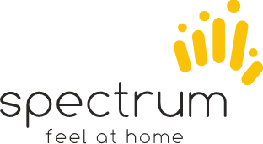

MHSS
SUPPORT WORKER MANUAL

We at Spectrum gratefully acknowledge the Wurundjeri people as the traditional owners and custodians of the land in which we work, and pay respect to their elders past and present.

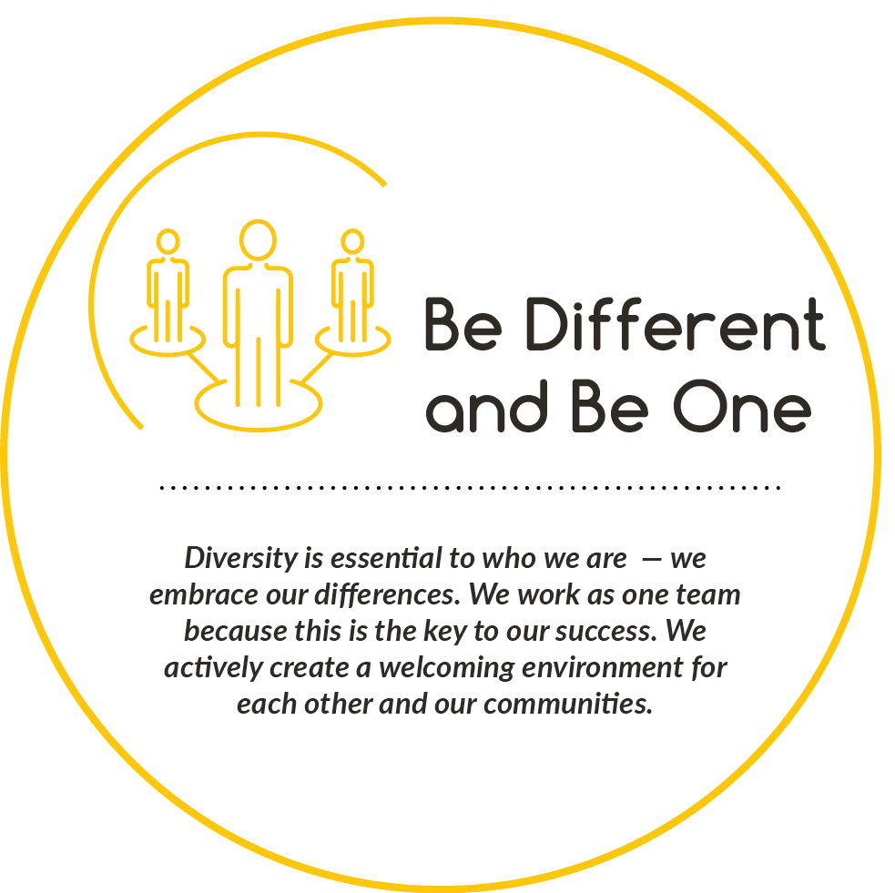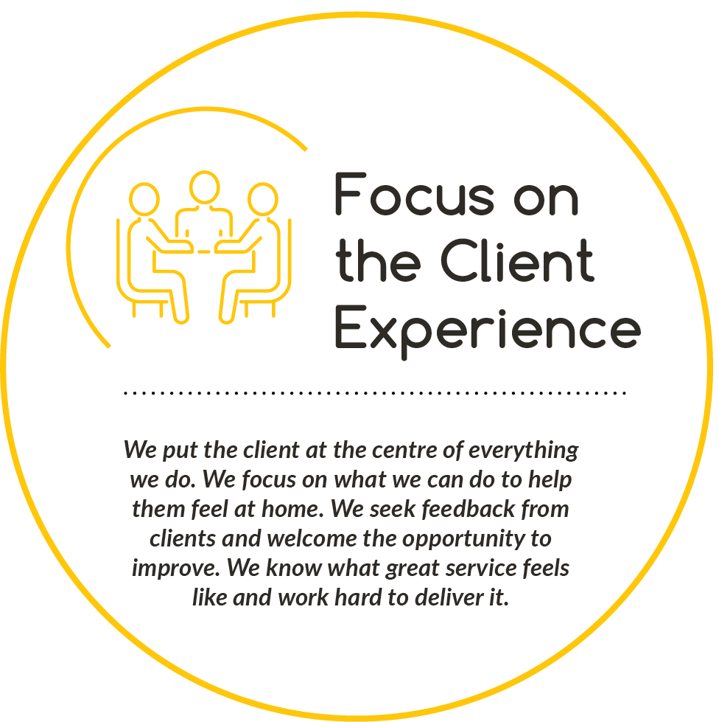
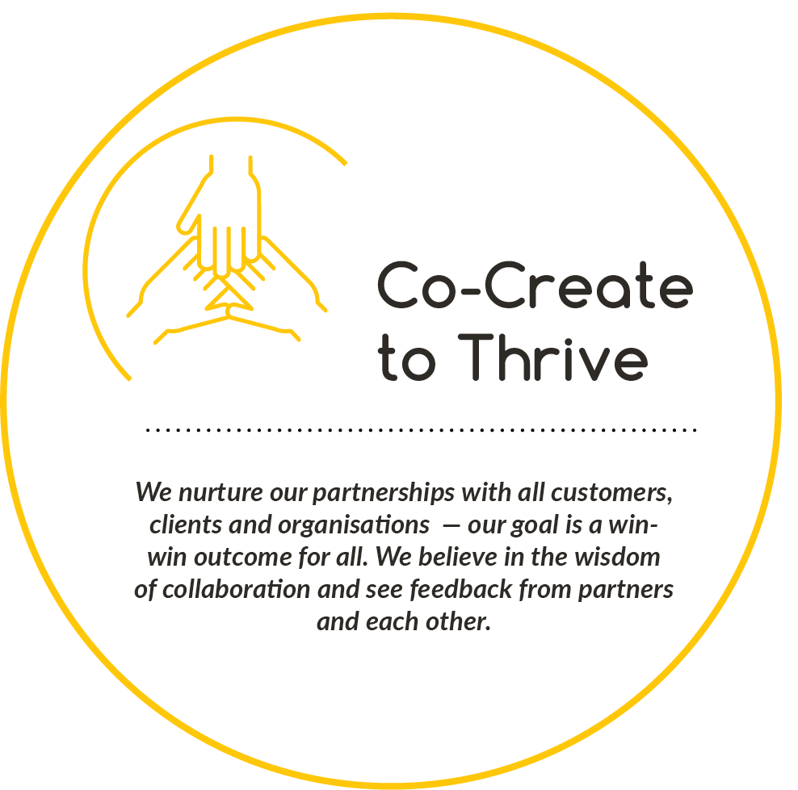
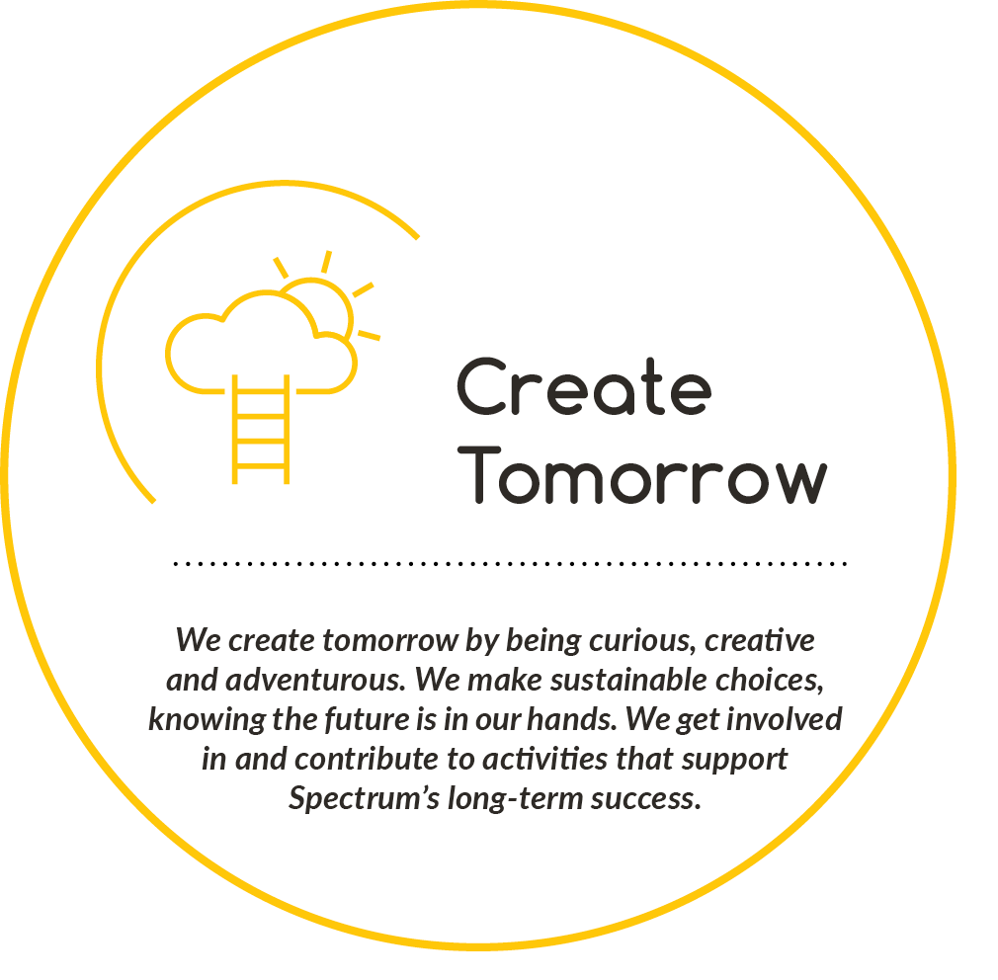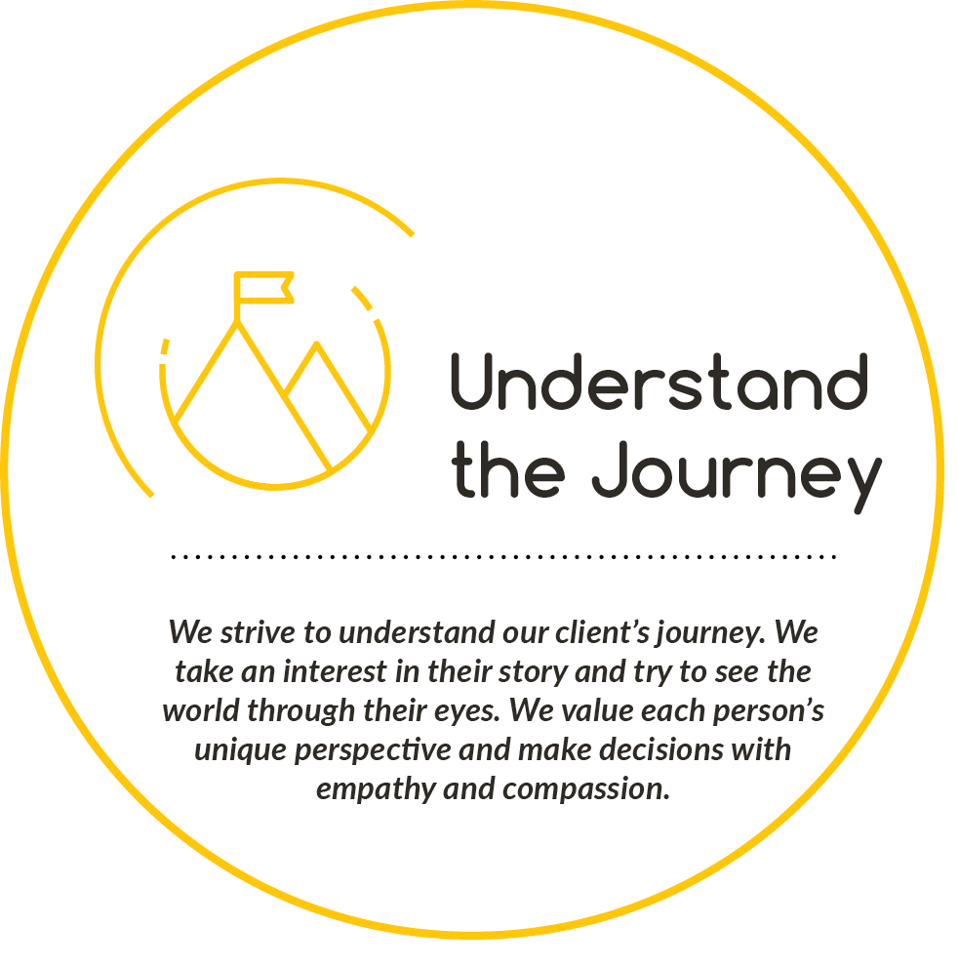
Welcome Home!
Firstly, we would like to welcome you to Spectrum and hope that your time with our organisation is fulfilling and a positive contribution to your career within the aged and disability sector.
Our aim is to make your employment with Spectrum as rewarding as possible, and at the same time providing the best level of support for our clients to meet their goals.
As a MHSS – Multicultural Home Support Services Support Worker you are a valued member of the Community Services team, all of whom are skilled, well-trained, committed and caring people. In your role, you will visit clients in their own homes and for them you will be the “face” of Spectrum. How you interact with, and the relationship you have with your clients is very important as it will influence what they think of the Organisation.
This MHSS Support Worker’s Handbook has been developed to:
- Give you an overview and understanding of MHSS’s purpose, principles and underlying values base
- Give you an understanding of MHSS’s way of providing services and supports that will encourage and support “older people to live well”
- Assist you to understand how you, as a member of MHSS, can play your part in the provision of high quality and consistent services to our clients
- Provide you with a reference and guide to assist with your day to day work. How we think about the work we do
At Spectrum we think about aged care services a little differently. It is our role to assist older people to achieve this by providing the support and services that enrich their lives, enabling independence, and remaining active and engaged. We believe older people can continue to lead fulfilling and meaningful lives — the life they want.
It is our clients who tell us that independence and staying connected to home, family and community is important. As much of your work will be completed in clients’ homes, it is important you understand and respect their rights and that you have a clear understanding of your role and responsibility.
If you have any questions or are ever uncertain about what is expected of you, you are welcome and encouraged to call into the office or phone your MHSS Office team at any time.
Please read this Handbook, together with your position description, your contract of employment, the Welcome to MHSS’s Booklet and Spectrum’s policies and procedures which can be found in your welcome pack.
I hope that your employment with Spectrum is fulfilling and enjoyable and gives you the satisfaction that you are making a difference in the lives of others. Again, I extend a warm welcome and offer my best wishes and support to you in your work.
Welcome to Spectrum, a not-for-profit community organisation with a long history of providing high levels of support and care to clients in the community and residents in its aged care homes across Melbourne.

Bernie Nott
Chief Executive Officer
About
Spectrum enables people with migrant and refugee backgrounds to feel at home in Australia.
Spectrum delivers services to newly arrived and established people with migrant and refugee backgrounds.
We provide services in these core areas:
- Multicultural Home Support Services
- Settlement services
- Family Services
- Youth services
- Disability Service
- Commonwealth Home Support Program
- Support for Carers Program

Aged Care Awareness
Here at Spectrum we provide support to elderly client in the community.
We follow a consumer directed care (CDC) model when delivering age care support, ensuring that clients are given more choice and flexibility when making decisions about the type of care and services they will receive.

When providing care to elderly clients, they may require your support for varying reasons such as:
Ageing In-Home: When an individual and or their family want the care recipient to stay in their own home, however they require assistance with things like showering, grooming, preparing meals and cleaning or with transport so that they can go shopping or attend appointments.
After Hospital Care: When an individual has been in hospital, and needs extra support around the house whilst they recover.

Disability Awareness
With the focus on the person as a whole, the defining of disability is more about individual differences as part of the diversity of a community that is similar to cultural backgrounds and abilities.
The focus is on an individual’s strengths and abilities rather than their disability or difference.
As a disability support worker, you may work with people with a range of disabilities during your employment with Spectrum.

Models of Care Support Practice at Spectrum

To assist you to have an understanding of some different approaches in working with people please chat with the MHSS Office Team about the following definitions.

Person-Centered Care/Approach
A person-centered approach recognises that the older person is at the center of services and the person is active in decisions about their care and support. It recognises that the relationship between the support provider and the older person is a partnership and collaboration and respects the individual differences of the older person.

Consumer Directed Care
Is a service model that empowers individuals and their carers by expanding the degree of choice and control over the services they receive at any age.

Active Service Model
Is a model that was designed to increase client independence through a person- centered approach. It acknowledges people want to remain as independent as possible - have choice, make decisions and do it their way.
It acknowledges people have the potential to improve their health and wellbeing (capacity).

The diagram below shows all the key elements that are important to any person. As well as these elements, consideration needs to be given to the individual’s life experience and the circle of support they have in place (family, friends, and neighbours).

Each person we come into contact with, every person we support, needs to be seen as an individual with an individual life story, individual experiences and individual lifestyle choices and preferences.

The positive health benefits for people that are attributed to maintaining significant relationships are another key factor to keep in mind.

To ensure that our services, care and support are of high quality it is important to think about all these areas as you are working with your clients.

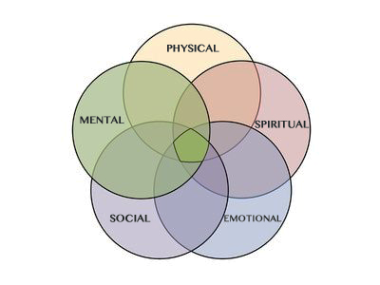

Multicultural Support Services MHSS
Community Support Services are provided to older people and people living with disabilities to enable them to remain independent in their own homes and to avoid early admission to residential care. The support services are wide ranging and designed to be flexible enough to meet the individual needs of each client.

Spectrum is committed to maximising client independence by working with each person to let them decide what they need and how we can assist them to be involved in the services they need (it is what is often called person-centered and capacity building approaches to service delivery.) We need to encourage clients to be as actively involved in their own care as possible and for them to make decisions about their healthcare and wellbeing.

Keeping people healthy and active even in small ways is beneficial. This includes supporting people to keep doing as much for themselves as possible.

By working in this way, you will ‘work with clients’ to assist them to do as much as they can for themselves, but you will still assist clients with the things they find difficult to manage. People want to feel that they are independent so supporting them to achieve this is important to us.

In working with clients in this way you will find you have more flexibility within the task list depending on the wishes of the client. Clients will have more flexibility and you will be assisting clients to achieve goals that they have set. Looking for the successes and assisting clients to understand their success will be an important part of your role.

At Spectrum we see the role of Support Workers as really important to support the very best outcomes for clients. It is your work with older people that contributes to the care and support to enable them to live a good life.

Services Offered by Spectrums MHSS Team

Home Care
Home Care covers domestic care or housework, including cleaning and other activities of daily living.

Working with your client to keep their house clean may include such activities as:
- Cleaning floor surfaces including vacuuming, sweeping and mopping of floors
- Dusting and polishing furniture and woodwork
- Wiping stoves, fridges, microwaves, benches, toilets and commodes.
- Reading correspondence at the request of the client
- Changing / Washing bed linen and towels
- Washing, Hanging out and bringing in washing
- Ironing (only ¼ of the shift can be designated to ironing)
- Meal preparation
- Unescorted (without the client) Shopping and paying bills

Home Care does not include the following tasks:
- Gardening or outdoor maintenance/cleaning
- Washing walls
- Taking down or putting up curtains
- Dry mopping
- Turning mattresses
- Cleaning outside windows
- Washing cars
- Polishing furniture
- Hand washing of clothes

Personal Care

- Personal Care includes assistance or supervision with activities that support clients to eat well, get out and about and manage personal tasks such as:
- Bathing, showering or sponging, Dressing and undressing, Drying, Applying deodorant
- Cleaning of teeth and dentures
- Shaving (with electric shaver only)
- Toileting
- Dressing and undressing
- Personal grooming (hair brushing) including,
- Assistance with mobility (e.g. in and out of bed)
- Assistance with eating and drinking, including cooking and/or preparation of special diets
- Fitting and use of appliances and equipment such as splints, callipers or hoists Assistance with prescribed exercise or therapy programs
- Assistance with fitting compression stockings, hearing aids and communication devices
- Transporting and accompanying the client to activities, appointments, shopping etc.
- Accompanying to recreational or social activities
- Assistance with managing medication e.g. (prompting to take prescribed medication)
- Light Home Care
- Application of non-medicated moisturizer

Respite Care

Respite Care refers to personal and Community Support Service activities and/or outings provided with the client to give their support person or carer, a period of respite to enable them to do the things that are important to them (to give them a break and some free time). This care and support are available any day and time of the week as required - including evenings, overnight and /or carer wishes.

As a Support Worker you may be required to assist clients to connect with an interest group, meet up with friends or other social activities or with managing self-care tasks. Activities may include:

- Accompanying to, provision or supervision of recreational or social activities
- Taking the person for a drive or enjoying shopping or coffee
- Assistance with prescribed exercise or therapy programs
- Assistance with mobility (e.g. in and out of bed)
- Assistance with managing medication e.g. (prompting to take prescribed medication)
- Assistance with eating and drinking, including preparing of light meals
- Personal care including toileting
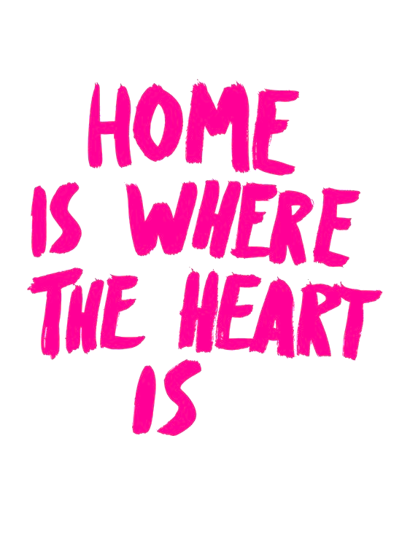

Spectrum’s MHSS – Multicultural Home Support Services Team
Team Members

The MHSS Team structure comprises of:
- Support Centre Manager
- MHSS Rostering Coordinator
- Support Worker Coordinator
- Care Administrators
- You and other Spectrum Support Workers supporting Spectrum Social Groups

The role of the MHSS Rostering Coordinator
- Coordinate the Care Administrator Support Services Team
- Ensure client services functions efficiently
- Provide overall support and direction to team members
- Ensure all staff have the training, equipment and skills to undertake their role
- Ensure that client services are arranged so that clients have quality services

The role of the MHSS Support Worker Coordinator
- Provide individual support and advice to team members
- Develop a strong compliant support worker force
- Provide appropriate advice, support and assistance to the Support Workers
- following any incidents/injuries

The Role of the MHSS Care Administrators
- Roster new client requests/shifts,
- Be your first of contact to assist and support any Support Worker queries
- Roster and accommodate, support worker leave to ensure clients have continuity of care.

Your role as a Spectrum Support Workers is to:
- Provide a flexible, professional service to meet the client’s needs
- Remember that you are our eyes and ears. Report all hazards and incidents/injuries to the MHSS Care Administrator Team immediately.
- Listen to the story, wants and desires, likes and dislikes of your clients
- Interact with all clients in a supportive and non-judgmental way. Support clients to achieve a balanced and satisfying quality of life
- Encourage clients to retain their independence by not taking over things they can do for themselves
- Monitor clients’ well-being and report any concerns to the MHSS Office Team Limit unproductive travel time and maximise work opportunities
- Support other members of the team
- Abide by the Spectrum Support Worker Code of Conduct in every respect
- Adhere to Spectrum’s polices, procedure and work instructions
- Act in a way that always puts the health and safety of the client and yourself as a piority

Team Meetings
Team meetings are held at regular intervals at our Dallas Office or other designated locations.
You are required to attend all Team Meetings unless a scheduled service is not able to be changed, or you have been given prior permission not to attend the team meeting by the Team Leader.
At the meeting:
- We pride ourselves in communicating respectfully.
- Any discussion about client issues is to be respectful of client confidentiality
- Gossip about clients is NEVER permitted
- Gossip about other staff is NEVER acceptable
- Each person has a responsibility to support other team members in a positive and courteous manner.
- A delegated person minutes the Support Worker meetings and these minutes are provided to all Spectrum Support Workers.

Team Meetings provide:
- Opportunities for Support Workers to meet each other and to be familiar with the team
- Training and staff development
- A forum where staff can share ideas and be involved in problem-solving, including resolution of Occupational Health & Safety (OHS) issues.
- Industry and organisational developments

Spectrum Support Workers:
Roles, Rights and Responsibilities
What does your clients expect of you?
Clients expect that you:
- Support them to achieve their goals and promote their independence
- Are reliable and punctual in attending to your rostered jobs
- Are flexible in accommodating cancelled or additional jobs and their changing needs
- Relate to them in a friendly, caring and sensitive manner and build a supportive, trusting and professional relationship with them
- Respect their wishes and choices, as long as these are within the scope of your job and do not present a hazard to yourself.

Role of a Spectrum Support Worker
It is every employee’s responsibility to maintain a person-centered approach, where the needs and wants of the clients determine the care plan.

Like all organisations, Spectrum has an employee code of conduct, which you are expected to follow.
These standards are based on the premise that all Spectrum clients whether individuals or organisations, can expect to be provided with professional service by appropriately qualified and experienced staff.

All Spectrum support workers are expected to:
- Demonstrate current knowledge, skill, care and courtesy at all times.
- Adhere to policies and procedures as specified by the contracting organisation.
- Attend allocated work at the specified time or as determined by Spectrum.
- Approach clients, staff and members of the public with courtesy at all times.
- Work within occupational health and safety standards.
- Be appropriately dressed at all times.
- Respect the rights of the clients and organisation to confidentiality.
- Conduct themselves in a professional manner at all times, as they are representing Spectrum.
- Ensure they have appropriate information at the commencement of each shift.
- Be aware of the duty of care responsibilities and to work in a safe and professional manner.
- Approach all individuals with respect, dignity and as valued clients of Spectrum.

Clients’ Rights and Responsibilities
All Community Support Services staff owe clients a duty of care and it is particularly important that their rights are acknowledged and promoted in all aspects of care.
Clients also have a responsibility towards you, other service providers and sometimes other clients.

Clients have the right to:
- Be treated and accepted as an individual, and to have their individual preferences respected
- Be treated with dignity, with their privacy respected. Receive care that is respectful to them, their family and home. Receive care without being obliged to feel grateful to those providing their care
- Full and effective use of all their human, legal and consumer rights, including the right to freedom of speech regarding their care
- Be treated without exploitation, abuse, discrimination, harassment or neglect. Be involved in identifying the community care most appropriate for their needs
- Choose the care and services that best meet their assessed needs, from the community care options and within the limits of the resources available
- Participate in making decisions that affect them
- Have their representative participate in decisions relating to their care if they do not have the capacity
- Receive reliable, coordinated, safe, quality care and services which are appropriate to their assessed needs
- Be given before, or within 14 days after they commence receiving care, a written plan of the care and services that they expect to receive
- Receive care and services as described in the plan that take account of their lifestyle, or other care arrangements and cultural, linguistic and religious preferences
- Ongoing review of the care and services they receive (both periodic and in response to changes in their personal circumstances), and modification of the care and services as required
- Privacy and confidentiality of their personal information
- Access their personal information
- Be assisted to understand any information they are given
- Be given a copy of the Charter of Rights and Responsibilities for Home Care. Be offered a written agreement that includes all agreed matters
- Choose a person to speak on their behalf be involved in their care and support for any purpose
- Be given information on how to make comments and complaints about the care services they receive
- Complain about the care and services they receive, without fear of losing the care or being disadvantaged in any other way
- Have complaints investigated fairly and confidentially, and to have appropriate steps taken to resolve issues of concern
- Have their fees determined in a way that is transparent, accessible and fair. Receive invoices that are clear and in a format that is understandable
- Have their fees reviewed periodically and on request when there are changes to their financial circumstances
- Not to be denied care and services because of their inability to pay a fee for reasons beyond their control

Clients have a responsibility to:
- Respect the rights of SWs to their human, legal and industrial rights including the right to work in a safe environment
- Treat SWs without exploitation, abuse, discrimination or harassment. Abide by the terms of the written agreement
- Acknowledge that their needs may change and to negotiate modifications of care and service when their care needs do change
- Accept responsibility for their own actions and choices even though some actions and choices may involve an element of risk to themselves
- Give enough information to assist the approved provider to develop, deliver and review a care plan or task list
- Tell the approved provider and their staff about any problems with the care and services
- Allow safe and reasonable access for SWs at the times specified in their care plan or otherwise by agreement
- Provide reasonable notice if they do not require a service
- Provide appropriate tools and equipment for SWs to perform the approved tasks safely and efficiently.

What does Spectrum expect of you?
Spectrum expects that you:
- Comply with the Spectrum’s Code of Conduct. Have a clear understanding of your role and responsibilities
- Only provide care and services which you are trained and qualified to provide within the scope of your role
- Follow the instructions and directions in this manual and other resources and training given to you
- Follow the directions of your MHSS Office Team
- Understand and respect your clients’ rights, including their right to dignity, individuality, privacy and confidentiality
- Monitor the wellbeing of your clients’ and immediately report any change in their health or wellbeing to your MHSS Office Team
- Advise the MHSS Office Team of any requests made by clients for service changes or if you are uncertain about any aspect of your role
- Report any changes to the client's health, welfare or wellbeing to the MHSS Office Team
- Immediately report any abuse or suspected abuse of a client or other family member to the MHSS Office Team. Do not discuss with the client or family.
- Work the hours you are rostered and be reliable and punctual in attending to your rostered jobs (any changes in shift time or day require prior authorisation from the MHSS Office Team)
- Be available for work within the period of your nominated availability
- Are flexible in accommodating cancelled or additional jobs and the changing care needs of clients
- Familiarise yourself with all Spectrum policies and procedures all documentation supplied to you by Spectrum and be familiar with its application
- Immediately report any hazards, incidents, accidents or injuries to the MHSS Office Team
- Immediately report if you have misplaced or lost your roster/ timesheet or any client information to the MHSS Office or the After-Hours Support Service (AHSS)
- Report any tools or equipment that are malfunctioning or not appropriate for the tasks
- Behave in a safe manner so as not to endanger the health, safety and wellbeing of yourself or the client, in accordance with the Occupational Health and Safety (OHS) guidelines and training provided to you
- Refrain from selling or promoting any products, political or religious material or beliefs
- Refer any requests for information about your client or about Spectrum to the MHSS Office Team.

Professional Boundaries
- Understand and respect Professional Boundaries: It is recognised that a strong rapport will develop between the support worker, clients and their families, however support workers must maintain professional boundaries at all times.
- Professional boundaries are limits, which protect a worker’s professional power and their client’s vulnerability. These boundaries are important as they allow for a safe connection between the SW and the client.
- Failure to adhere to professional boundaries may result in performance management, which could lead to termination of employment.
Examples of unacceptable actions related to professional boundaries are to:
- Seek out a personal relationship with your clients, nor with their family.
- Have a sexual relationship with clients, nor with their family.
- Hug or kiss the client (a handshake for greeting is acceptable)
- Introduce clients to your own family, friends.
- Socialise with clients outside of work hours.
- Do not arrive late and leave early.
- ask for or accept gifts or special favors from your clients
- allow clients to drive your own motor vehicle
- give advice or act as an interpreter outside of your skills and expertise
- Negotiate private arrangements or accept private work.
- Enter the client’s home without the client being present.
- Visit the client when they are in hospital or respite care.
- Attend to clients who are found out to be related to the support worker.
- Seek from the client or provide to the client any financial assistance, for example borrowing, lending or accepting money.
- Take any of their client’s belongings
- Disclose and/ or receive personal information including
- Phone number
- Address
- Health Status, Financial Status, Relationship Status

Client Relationship
Your clients are to receive the timely attention and the positive response and support which is required of you in your role.

As said in the “Welcome” in the front of this Handbook, the relationship you have with your clients is also very important.
Our relationships with all people we know, whether they be family, friends, work colleagues or clients, are individual and develop differently over time: with some people we become closer to over time, some we have more in common with than others, some we like more than others and some we may want to help more when they are experiencing a difficult patch in their lives.

This is no different with clients and we know that there will be some clients that you will become close to over a period of time. We believe it is important that positive, caring and trusting relationships are formed with clients and that it is the strength of these relationships that can encourage clients to remain as active, engaged and independent as possible.

Over time, as you continue to support a particular client(s) on a regular basis, you many develop a personal friendship with one or a few clients. This is understandable and the natural way for friendships and relationships to develop.

However, in your role of giving, supporting, caring, listening and encouraging clients you need to recognise that you may also need support to enable you to do your work well and not to be “burdened” by any problems the client may have. If that occurs you are to seek and request support from your Manager.
At times it may be appropriate for the client to know a “bit” about you, such as the names and ages of your children, their interests, your hobbies, etc., particularly if and when it helps to provide empathy with a client’s own experience.

However, this sharing should not be done to burden a client with any of your personal issues or problems. You need to always remember that you are serving the client and not vice versa.
In saying that, clients will sometimes want to do something for you or to give you something and it is most natural and appropriate to do so when a trusting relationship has developed.

We all get more from giving than receiving and of course that applies to clients, too. Common sense plays a big part in what is appropriate and what is not appropriate to accept (please familiarise yourself with the Gifts Procedure). It is quite acceptable to accept a card, some fruit from a tree in the client’s garden, or a cake that has been baked or to accept a coffee on an outing with a client.

Likewise, it is a wonderful and acceptable gesture, if, at times you freely do a little something extra for a client, as a personal choice and freely given in your own time — the same as we would do for a_ friend or family member. This could include buying the client a coffee when you are on an outing with them or visiting the client in hospital or driving them to a Church service or driving them to a funeral. The important thing to note is that it is not a requirement or expectation of your job to do “extra things” and that, if you choose to do so, it must be on the basis of not receiving anything material in return.

What can go wrong?
We recognise that as you work on your own and as the nature of the work you do is quite personal there may be times when clients and/or family members make requests that are not appropriate and/or sit outside of the responsibilities you are able to take on. When feeling unsure or in doubt, you should seek advice from the MHSS Office Team. It is in your best interests, and will protect you if there was ever an issue raised, that you advise the MHSS Office Team if you intend to visit a client outside your normal shift times (for example, if the client is in hospital).

You are not to provide the client or their family with your personal contact details at any time (i.e. your phone number, email address or home address).
Changes or Extra Services to Clients
If you have any concerns regarding the level and type of services your client needs or wants, please encourage your client to speak with their Care Manager or Assessment Officer. You could also contact the MHSS Office Team and discuss your concerns. You must not suggest the introduction of extra services to your clients, or negotiate changes of service times.

Private Service Arrangements
You are only to provide Spectrum clients with those services that are rostered and authorised by the MHSS Office.
This includes being driven to a client's home by another person or leaving others in your car outside of the client's home, as this would be a potential breach of the client’s privacy. In the event that you cannot drive yourself on any occasion, you will need to discuss potential options with the MHSS Office Team.

If a client wishes to, and requests to meet one of your family members, please check with the MHSS Office before you agree to this.

Personal Values
The cleanliness and hygiene standards of clients’ homes and their choice of lifestyle will vary. It is important that you remember that personal values and acceptable hygiene standards will differ from client to client and may be different from yours. Our standards do not always suit everybody. The client may like to keep papers about the place whilst you prefer that they are thrown out immediately, so do not worry, that’s their choice.

If a client’s standards are in danger of causing a health or other risk to themselves then we need to follow up on your concerns. Report any concerns about a client’s safety to the MHSS Office Team and fill out a Hazard Report.

Time sheets Management
- A fortnightly timesheet will be mailed out to Support Workers one week in advance
- Any additional shifts that are added after the timesheets have been sent out must be documented on the manual timesheet by the Support Worker
- In order to comply with Privacy Legislation, Support staff must always use their Spectrum Privacy Time-sheet Folder as demonstrated during Induction/Training. When obtaining signatures from clients at the end of their shift, Support Workers must ensure that the details of other clients are not visible.
- Note that it is one manual timesheet per client. Support Workers cannot record multiple clients on the same manual timesheet.
- It is important that timesheets reflect the exact arrival and departure times of the Support Worker.
- Changes to arrival and departure times or extensions to shifts can only be approved by the Office.
- Extensions to shifts occurs when a Support Workers stays beyond their rostered time without Office approval
- Any changes, in particular extensions to shifts that have not approved by the office will not be paid.
- Times-sheets are legal documents and are subject to Auditing. Support Workers must ensure that no comments at all are written on the Time-sheets either by themselves or their clients.
- Hours WILL NOT be paid where the client’s signature is not provided unless this has been negotiated with the Office (for example the client is unable to sign).
- Timesheets must be sent to the relevant Office on every second Monday by 12noon as per the calendar given at induction training
- Late timesheets will not be processed unless approved by the Support Centre Manager
- Timesheets sent Via email are to Scanned and sent in PDF format to timesheets@spectrumvic.org.au
- Timesheets sent via Fax are to be sent to 94960240

Identification Badges
- You will be asked to provide a photograph (passport size or smaller) or be willing to have your photograph taken for an identity badge.
- Identification badges are to be worn whilst at work and are to be kept in a secure and safe place when not at work.
- You may remove your badge once the client has seen your identification.

Vehicle and Driving Responsibilities
Driver’s License
- All SWs who are required to drive a vehicle are to have a current Australian driver's license or equivalent. You are required to advise your MHSS Office Team immediately if you:
- Are required to take any medication that may affect driving
- Have been convicted of a traffic-related offence, or
- Have had your license suspended or cancelled.

Registration and Insurance of Private Vehicle
Where you are required to use your own vehicle, you are to ensure that the vehicle is:
- Kept in a roadworthy condition — if car is not roadworthy, insurance may not cover cost of repairs
- Registered
- Mechanically fully maintained
- Clean, including free from pet hair and odour.
Where there is a requirement to transport clients, including children, it is to be suitable for that purpose (including having temperature controls that are suitable for the weather conditions i.e. heating or air-conditioning).
Seat belts or an approved child restraint are to be worn at all times and loose items are not to be left in the inside of the vehicle where they could become projectiles.
At the commencement of your employment with Spectrum staff from the MHSS Office Team are required to conduct an appropriate visual check of the vehicle that you will normally be driving in the course of your employment with Spectrum and then on an annual basis.
You will be asked to complete a MHSS Staff/Volunteer Private Vehicle Checklist every twelve (12) months as proof of the suitability or your vehicle for transporting clients, including children. You are to provide a copy to the MHSS Office Team.
At the commencement of your employment with Spectrum and whenever they are updated or renewed you will be required to provide a copy of your current (and where appropriate proof of payment):
- Driver’s license
- Certificate of registration/third party insurance
Comprehensive motor vehicle insurance cover is highly recommended. Any damage to your vehicle or to other property caused by you while you are driving your vehicle for business use will be your responsibility.
Penalties and fines
- Drivers are liable for parking infringement fines and penalties imposed by traffic law offences. This also includes fines for the use of mobile telephones whilst driving.
- When using a client’s disability parking permit whilst transporting them to and from appointments, please ensure that you check to see if client’s disability parking permit is current.

Travel Claims
- Support Workers are entitled to claim for kilometers travelled during their shift. For example, from the client’s house to the doctors and back to the client’s house. This does not include travel from the Support Worker’s house to the client’s house and travel in between clients.
- Support Workers are encouraged to maintain a log book to record kilometers travelled between shifts for their own tax claim purposes.
- Support Workers are only permitted to transport clients if it is agreed to and documented on the Care Plan.
- In these instances, the Support Worker must use their own vehicle.
- If transport has not been agreed to in the Care Plan, Support Workers are to obtain authorisation from the Office.
- Support Workers are obligated to have comprehensive car insurance and ensure that their vehicle is roadworthy.
- Support Workers are encouraged to have full road side assistance policy.
- Kilometers limitation will be stated on the Care Plan and also recorded on the timesheet.
- Any additional kilometers must be pre-approved by the Office.
- Claims for kilometers must be lodged on a travel claim form with timesheets on a fortnightly basis.
- When completing the travel claim form the Support Worker must record the actual kilometers of travel and a clear indication of the destination for each client transported during the fortnightly pay period.
- Support Workers can record multiple clients on one travel claim form.

Travel Allowance
- In acknowledgement of the travel required as part of the MHSS role and increasing cost of petrol, Support Workers who undertake 5 or more shifts per fortnight will be eligible for a travel allowance as per the MHSS Workplace Agreement.
- The amount of travel allowance will depend on the number of shifts undertaken per fortnight.
- Travel allowance is in addition to any travel claims for transporting clients to appointments, shopping etc.
- Travel between shifts must be recorded in a Log Book, which can be purchased from a newsagent or stationery, and it is Tax deductible.
- Support Workers must be aware that Car Insurance is also Tax claimable

Mobile Phones
- Support Workers are required to have a personal mobile phone for work purposes.
- It is the Support Worker’s responsibility to ensure that the phone is able to make and receive calls and the phone is fully charged and in credit or on a plan.
- Please ensure that you have a voice mail messaging service.
- The cost of the mobile phone is tax deductible
- Support Workers are requested to use their discretion when answering mobile phones when on duty.
- Support Workers must not answer their mobile phone while driving as this is illegal and places both the Support Worker and the client at risk. When safe to do so, Support Workers should pull over to the side of the road and to respond to work related calls.
- Spectrum encourages Support Workers to purchase a hands-free car kit which is tax deductable
- Whilst on duty, it is preferred that your mobile phone is used only for work related communication, or if a worker needs to be contacted urgently in the case of an emergency by family members.
- Support Workers must ensure that mobile phone ringing or communication does not disturb the client at any time by switching your phone to the vibration or silent mode.
- Support Workers must use their personal mobile phone when making calls to the office or the After-Hours Phone.
- Support Workers are not allowed to use the client’s home phone except on an emergency, for example, calling for an Ambulance.
Gifts
- Support Workers are not permitted to give or accept gifts or goods from clients and their families.
- The only exception to this is authorisation to exchange small culturally significant gifts for holy/religious occasions. All such gifts must be reported to the Office.

Purchasing items on a shift
- Support Workers are reminded that they are not to purchase items for themselves whilst supporting clients.
- This is to avoid any confusion about who paid for the item and ensures you are providing your full support at all times.
- The only item acceptable for Support Workers to purchase on a shift is a meal or drink if the shift involves sharing a meal or a drink with the client.

Religion/Politics
- Support Workers are asked not to discuss party-political or religious issues with clients and families.
- Discussions relating to world and local affairs of interest to the client are acceptable, as are discussions relating to ageing, health and dying, which may raise spiritual or religious matters. If latter issues are of a particular concern to the client, the Support Worker must telephone the Office.

Driving/Alcohol/Drugs
- You are to take reasonable care and not put yourself or others at risk by your actions or omissions.
- This includes a responsibility to:
- Adhere to the Private Motor Vehicles used for Business Purposes Procedure
- Drive within speed limits
- Comply with drug and alcohol laws
- Use seatbelts and ensure clients, including children wear seatbelts or use of an approved child restraint
- Refrain from using the mobile phone, GPS or other devices whilst driving (even with a hands-free option)
- Complete the MHSS Staff/Volunteer Private Vehicle Checklist every 12 months and provide to the MHSS Office ensuring vehicle is registered and roadworthy

Using an E-tag
If you are authorised to travel on the City Link network for client purposes you will be reimbursed the cost of the toll. This will be recorded on your travel claim forms available at the Office.

Telephone and Mobile Phone Calls
Telephone Calls
Work related telephone calls pertaining to the client’s welfare are only be made from the client’s home if the matter is urgent, and with the client’s permission. Do not make personal calls or calls relating to another client from a client’s phone.

Mobile Phones
We recommend that you keep your mobile phone charged, turned on and on your person during work hours to enable the MHSS Office Team to keep in contact with you, and for your personal safety. All personal calls while rostered on duty are to be minimised.
Please remember to check your phone for missed calls or messages from the MHSS Office Team and return the call as soon as possible and confirm requests sent by SMS message.
You may be eligible to claim a tax deduction for the work-related use of your phone. You may wish to obtain advice from the Australian Tax Office, your Accountant or Tax Agent regarding this
Smoke-Free Workplace
You are not permitted to smoke at any time while providing care to a client. This includes while in the client's home, in a vehicle, including your own car while transporting the client, or at a community venue while providing support to the client.

Likewise, clients are asked to respect your right to a smoke-free environment by not smoking in your presence. If a client insists on smoking during your shift, explain that you are not allowed to work in that room until the smoke has cleared and advise the MHSS Office Team of the situation.

Spectrum’s Code of Conduct: Spectrum Code of Conduct 21062018 – Quality- v1
Spectrum has a clear expectation of appropriate work standards that foster a positive work environment where everyone’s rights are maintained.

All employees, volunteers and contractors of Spectrum will:
- act in accordance with Australian legislation
- act in accordance with Spectrum’s policies and procedures
- follow lawful and reasonable directives from management
- promote the interest of the business
- be aware of and align with the company’s purpose, vision and values
- work towards the achievement of the aims and purpose of the organisation
- whilst in employment with Spectrum, must provide services without engaging in abuse, exploitation, harassment or neglect
- act ethically, with integrity, honesty and transparency
- not engage in sexual abuse, misconduct or inappropriate behaviour and must report any such
- conduct to management by other workers, people with a disability, family members, carers or
- community members
- must report any form of abuse or suspected abuse
- must show respect for cultural differences when providing services
- maintain the confidentiality of the company, not disclosing or misusing company information
- take reasonable steps to avoid a conflict of interest, and disclose details of instances where this
- may occur with their direct supervisor
- be accountable for your own actions and decisions
- be ever mindful of the health and safety of yourself and others in the workplace
- uphold the principles of equal opportunity, not partake in victimisation, bullying, sexual
- harassment, discrimination or any other anti-social behaviours

All people working with children on behalf of Spectrum will:
- adhere to Spectrum’s Child Safe Policy and Child Safe Procedures to protect children from abuse. The seven Child Safe Standards are:
  - embedding a culture of child safety through effective leadership.
  - making a commitment to child safety with a policy or statement.
  - having a clear code of conduct that establishes appropriate behaviour with children.
  - screening, supervision and training for staff, to reduce the risk of child abuse.
  - clear processes for responding to and reporting suspected child abuse.
  - identifying child abuse risks and ways to reduce them.
  - empowering children to share their feedback and experiences about feeling safe.
- notify the Department of Justice and Regulation within 21 days of commencing child-related work with Spectrum and whenever your personal and contact details change and inform our Human Resources Manager when completed
- establish and maintain a child-safe environment
- treat children and young people with respect and value their ideas and opinions
- listen and respond to the views and concerns of children, particularly if they are telling you that they are or another child has been abused or that they are worried about their safety/the safety of another child;
- promote the safety, participation and empowerment of children with culturally and/or linguistically diverse backgrounds, children with a disability and Aboriginal children;
- comply with specific organisational guidelines on physical contact with clients and children
- respect the privacy of children, their families and carers and only disclose information to people who have a need to know in accordance with Spectrum’s Privacy Policy and Procedures
- contact the Police if a child is at immediate risk of abuse (telephone 000)

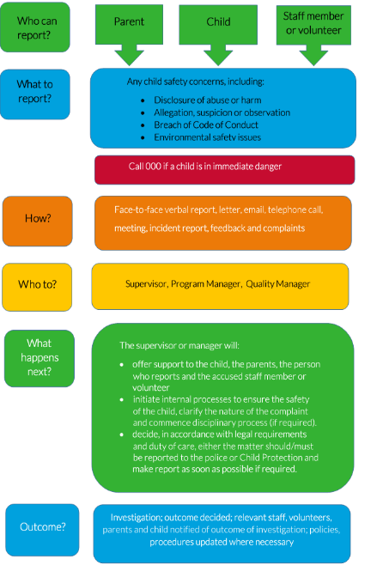

All people working with children on behalf of Spectrum MUST NOT:
- shame, humiliate, oppress, belittle of degrade another, including children and young people
- speak to a child in a way that is or could be construed by any observer as harsh, threatening, intimidating, shaming, derogatory, demeaning, or humiliating
- unlawfully discriminate against any child and young person on the basis of being culturally and linguistically diverse, having an Aboriginal background, a disability and gender and sexual orientation
- engage in an activity with a child or young person that is likely to physically or emotionally harm them
- initiate unnecessary physical contact with a child or young person, or do things of a personal nature for them that they can do for themselves including engaging in rough physical games, hold, massage, kiss, cuddle or touch a child in an inappropriate and or/culturally insensitive way
- be alone with a child or young person unnecessarily and for more than a short period of time
- have children spend the night at the residence of an employee, director, volunteer or contractor (and sleep in the same bed, sleeping bag, room or tent with a child while on camps or other alternatives of this nature)
- develop a ‘special relationship’ with a specific child or young person for their own needs
- show favouritism through the provision of gifts or inappropriate attention
- arrange contact, including online contact (including by social media, email, instant messaging etc.), with a client, child or young people outside of the organisation’s programs and activities
- have contact with a child or their family outside of Spectrum’s activities and any other contact that is outside of your professional relationship with the child
- photograph or video a client, including a child or young person without the consent of the client, child and his/her parent or guardian
- work while under the influence of alcohol or illegal drugs or provide or allow a child to consume alcohol or illegal drugs
- engage in an open discussion of a mature or adult nature in the presence of children or clients
- other than in an emergency or other abnormal situation where no other option could be reasonably foreseen, it is not acceptable to transport children without consent from their parent, carer or guardian
- do anything in contravention of the organisations policies, procedures or this Code of Conduct.
- For the purpose of this policy a child includes any young person below the age of 18 and can include a person above the age of 18 with an intellectual disability.

Breaching this Code of Conduct
- If you breach this Code of Conduct you will face disciplinary action, including and up to termination of employment or cessation of engagement with the organisation. Breaches may also result in criminal charges which will be dealt with by the appropriate authority.
- Spectrum will base all necessary disciplinary action on the principle of procedural fairness if you violate the obligations of this Code of Conduct.

MHSS Quality Service
Spectrum has a strong commitment to providing high quality, responsive services to meet the needs of its clients. We view a complaint as a positive opportunity to learn about the needs of others, or to learn from our mistakes, in order to provide improved service in the future.

Spectrum places great emphasis on quality, some examples of how we do this are:
- Policies, procedures and work instructions are in place for staff to follow to ensure we meet all legislative, regulatory standards and guidelines and maintain a consistently high standard in provision of services. These are reviewed and updated regularly
- Internal Quality Audit program- audits internal policies, procedures and work instructions. You may be asked to provide information about your understanding of procedures and work instructions relevant to your role
- A Feedback log is maintained for Improvement Requests arising from External feedback or from staff
- Spectrum, Complaints and Compliments System is provided to clients in the initial information pack on commencement of services and reviews. All complaints are taken seriously and appropriate action taken
- Staff, client and customer satisfaction surveys are conducted regularly.
Examples of actions that would not be acceptable are:
- A complaint from a client or staff member not being treated seriously and acted upon promptly
- A rude or negative response to the person making a complaint
- Not advising the dissatisfied person of all the available avenues for redress Failure to report a serious breach of policy by another employee
- Not fulfilling all obligation of the role.

Fairness for Staff and Clients
Diversity is to be valued and our aim is to ensure that all people are treated fairly and equitably. We need to respect individuality and the rights of clients/residents to make choices that meet their needs.
Any actual or suspected abuse of clients is to be immediately reported in accordance with Spectrum’s policy.

Examples of unacceptable actions are:
Any form of discrimination whether by age, gender, sex, sexual preference, marital status, family responsibilities, pregnancy, race, colour, religion, political opinion, national extraction, cultural identity, social origin, physical or mental impairment
Patronage or favouritism of any kind that results in an unfair benefit or detriment to others
Any abuse of a client whether it be physical, sexual, financial, emotional or by neglect of their needs
Recruiting a friend or relation without going through a transparent process
Gossiping, spreading rumours or socially isolating others.

Ethical Conduct
Your conduct is to be professional, ethical and above reproach at all times. You are required to carry out your duties in a politically neutral manner and are not to use your position for personal gain. This means doing your best to meet specified performance standards, Spectrum’s policies and legislative requirements.

Examples of non-acceptable behaviours are:
Any conflict of interest arising out of employment with Spectrum — you are required to disclose to your MHSS Office Team where there is potential for a conflict of interest
Unauthorised use of Spectrum’s facilities and/or equipment
Unbecoming conduct that would adversely affect Spectrum’s reputation or its clients
An unprofessional business or personal relationship with a client
Allowing unauthorised personal guests onto a site where they have contact with clients or access to confidential information.

Accountability and Due Diligence
You are required to perform your duties in a competent and capable manner and to exercise your best professional judgement so that the best interests of Spectrum are served at all times. You are only to perform duties that you are competent and legally qualified to perform and you are required to follow all lawful instructions from the MHSS Office Team.
Examples of behaviour that would not be acceptable are:
- Any non-compliance with legislative and/ or Spectrum policy requirements
- Poor performance of duties
- Non-compliance with a lawful instruction
- Improper, inefficient or ineffective use of Spectrum’s resources
- Not reporting any illegal or inappropriate actions that effect Spectrum staff, volunteers, clients
- Leaving your position while rostered without permission from your MHSS Office Team.

Confidentiality and Public Comment
As part of your work you may obtain private information about a client’s medical condition, personal and family history. The right to privacy and confidentiality of information of clients, staff and volunteers is to be respected at all times. Privacy laws prevent you from sharing information and these laws apply even after you have stopped working with a client.
You may only release information to a third party where there has been prior and appropriate authorisation. This includes neighbours and your family and friends that may enquire about your work. You are not to give information to anyone outside Spectrum except in an emergency. If you are asked any questions refer them to the MHSS Office and contact the office as soon as you can to advise and inform.
In particular, this applies to the release of information to the media or discussion with the media (this may only be done by the Chief Executive Officer (CEO)).
This also applies to the release of information or discussion with a politician about individual clients or any aspect of organisational business or issues.
This is to be done by the CEO only (or delegated by the CEO on a situation by situation basis).

Privacy of Client Information
Sensitive information is to be securely stored to ensure access cannot be obtained by any unauthorised person. Rosters/timesheets and client information is to be stored securely in your Support Workers satchel and carried in the car boot. It is not to be left inside your vehicle overnight. If it is misplaced, lost or stolen it is to be reported to the MHSS office team immediately.
Any information relating to a client that is no longer required for care provision is to be returned to the MHSS Office to be filed or destroyed if it is a copy and not required.
Examples of behaviour that would not be acceptable are:
- Improper use or disclosure of Spectrum staff, volunteer or client information without prior proper authorisation
- Gossiping about clients with other Support Workers and/or other clients
- Statements made to the press, Department of Human Services, Police, a Solicitor or to other unauthorised external bodies about Spectrum, staff, volunteers or its clients without proper authorisation
- Leaving confidential information unattended or not secured. This includes client information and your roster/timesheet.
- Contacting external agencies to request any information about a Spectrum servicing client(s).

Safe Work Environment
We all have a responsibility to create and maintain a physically and psychologically safe environment for staff, clients and residents. Any discrimination, harassment, bullying, intimidating behaviour or use of your position to gain an unlawful, immoral or emotional advantage over another person will not be tolerated. Appropriate disciplinary and/or legal actions may be taken.

If you are bullied, sexually harassed, abused or discriminated against
What is Bullying?
Bullying is repeated unreasonable behaviour directed towards an employee or group of employees (or other workplace participants) that creates a risk to health and safety.
Unreasonable behaviour means behaviour that a reasonable person, having regard to all the circumstances, would consider humiliating, undermining or threatening.
Any such type of harassment in the workplace is considered as unacceptable behaviour.
What is Sexual Harassment?
- A person “sexually harasses” another person if he or she:
- Makes an unwelcome sexual advance or request for sexual favours
- Engages in unwelcome conduct of a sexual nature
- Makes an unwelcome sexual advance or request for sexual favours e Engages in unwelcome conduct of a sexual nature
- In circumstances where a reasonable person, having regard to all of the circumstances, would have anticipated the possibility that the other person would be humiliated, offended or intimidated.

What is Discrimination?
The Equal Opportunity Act 2010 (Vic) and Federal legislation prohibits discrimination in employment on the basis of amongst other things: age, career status, impairment (disability), industrial activity, lawful sexual activity, sexual orientation, marital status, parental status, physical features, political belief or activity, race, religion, personal association, gender identity and breast feeding.

Violence, harassment, and intimidation
You have the right, and it is your duty to care for your clients, to ensure that you and they are not subject to any discriminatory or unlawful act, including:
- Verbal threats in person or over the phone
- Threats and/or advances of a sexual nature
- Threats and/or advances of a violent nature
- Bullying or
- Physical assault

You now have a duty of care to treat all actions of harassment, violence or abuse seriously and to take the appropriate action.
Contact Spectrum Office if you feel that carrying out your service is a threat to your health or wellbeing, if you experience any form of abuse, or if you have any concerns regarding the health or wellbeing of your client.

Reporting
Reports of bullying, sexual harassment or discrimination will, at all times, be treated seriously and investigated thoroughly and confidentially. It is important that you do not delay in reporting to the MHSS Office Team, so that the issue is documented and corrective action is taken.

In ensuring a working environment is free from discrimination, sexual harassment or bullying behaviour of any kind, Spectrum seeks cooperation from all our staff and volunteers.

Any breach of this Code may lead to disciplinary action being taken in accordance with Spectrum policy which will ensure natural justice is applied and procedural fairness is followed.

Email, Social Media and Internet Usage
Access to Email and internet is via Internet Explorer on work computers and is provided primarily as a business tool. Use of the Internet is to be limited to work related purposes and usage is monitored by our IT Department. Access is also available via home- based computers.

Our network can be accessed remotely and can be accessed by staff, either through a work computer or on a home computer if you have access.
It provides communication opportunities and stores a wealth of information. It can be used for teams to communicate information that only authorised staff can access, or it can contain information that is generally available to all staff.

All policies, procedures and forms are all securely housed on our network and the great news is they can be easily and quickly found. All policies, procedures and forms will be communicated.

Ask your MHSS Office team should you require or want to confirm any process relating to our email and internet usage policies.

If you use social media (including, but not limited to Facebook, Twitter and personal blogs) you need to be aware that all information contained and transmitted is regarded as being in the public domain, regardless of what privacy settings are applied. Please do not make any comments about Spectrum its staff or clients.

Dress Code
How you dress gives an impression to the client of the quality of your work, your attitude and the respect you show your clients and the way you value yourself. All SWs are required to present themselves in a clean and tidy manner.

Clothing is to be “neat casual” and appropriate to perform the tasks required. Appropriate clothing excludes the wearing of track suits, zip up casual jackets, denim, midriff tops, singlets, shorts, heavily monogramed tee shirts or sweat shirts, or sundresses without straps or with shoe string straps.
Staff who elect to wear a uniform and work twenty or more hours per week are provided with “two spectrum tops” at the time of employment and one top each year on your anniversary of service. Staff who work less than twenty hours a week are provided with “one top” at the time of employment and one top each year on your anniversary of service.
Staff are to discuss requirements for additional “tops” with the MHSS Support Worker Coordinator.

SWs preferably choose to purchase the uniform available from Spectrum and you are required to wear:
- Plain black or navy-blue skirt or trousers
- Button up short sleeve shirt and when cold, a navy or black button/zip up cardigan or vest
- Plain polo shirts are permitted for SW’s

Where the client is being taken on an outing and where the client requests that the SW not wear a uniform you are to wear neat and tidy, appropriate clothing as indicated above. The MHSS office team will usually be able to let you know about this before the visit.

- Support Workers are issued with a polo t-shirt on commencement with the Spectrum logo that they are required to wear at all times, unless supporting clients from Disability, or when a special request from a client through the Case Manager is received and approved by Spectrum.
- Staff must provide their own trousers/skirt and non-slip, flat, closed in shoes.
- Support Workers must also wear a Spectrum photo identification badge at all times when working.
- Support Workers must ensure they are well groomed and neat at all times.
- If a Support Worker would like a second t-shirt, this can be purchased for $15.00.
- If a Support Worker is providing support for a disability service provider, they will be instructed not to wear a uniform during the shift.
- Support Workers who wear specific clothing for a religious purpose (e.g. hijab) can choose not to wear a uniform.
- Australian Taxation regulations have been adhered to enable additional corporate garments purchased by employees to be tax deductible.
Uniforms supplied to employees will remain the property of Spectrum however full responsibility for maintenance and cleanliness will remain with each employee, including exchange of damaged uniforms.
Uniforms are to be returned to your Spectrum Office on cessation of employment. 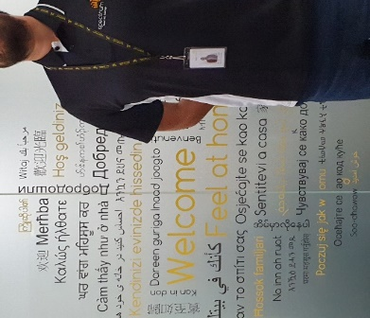

Hours of Work and safety
- Both Spectrum and you have an obligation to ensure a safe work environment. This includes ensuring that you work reasonable hours rather than excess hours. When the MHSS Office Team is setting up your roster/timesheet they will ensure that your work is rostered to avoid:
- Excessive hours having regard to the Act and OHS obligations
- Regular shifts longer than 10 hours and
- No combination of regular and overtime hours in excess of 12 hours on any one shift

If you work for more than one employer you need to tell the MHSS Office Team to ensure they comply with Spectrum’s ‘Reasonable Hours’ policy. You are to ensure that:
- The actual hours you work in any one day are worked in a manner that is safe. This requires a reasonable break between finishing work with one employer and starting the next shift with Spectrum
- The total hours worked in any week are not excessive. By ‘Excessive’ Spectrum mean an amount more than 38 hours per week that may prevent you from performing your work in a safe manner.

If you believe you are scheduled to work excessive hours, you are to notify the MHSS Office Team. The MHSS Office Team may ask you to take steps that are necessary to ensure your safety, and that of other workers and clients. Where your roster/timesheet is changed for this reason, there will be no penalty to Spectrum as a result.
Where your roster/timesheet cannot be changed, you are to ensure you alter your work roster with the other employer to make sure you do not work unreasonable hours.

Notification of Absence
If you are sick or unable to work for any other reason, you need to inform the MHSS Office Team as soon as possible, preferably not less than two (12) hours before the commencement of your rostered shift. If you wish, you can give the staff information about the nature of your illness and how long you are likely to be off work. If the shift to be missed starts before 10.30am or earlier, you are to leave an after-hour’s voicemail.
Spectrum Multicultural Home Support Services

Phone Business Hours | 1300 735 653  (Mondays-Fridays 8:00am – 20:00pm)
Voicemail After Hours | 1300 735 653 (After 20:00 pm)
 | Voicemail service, to be actioned the following business day
Address | Level 5, 61 Riggall St, Dallas VIC 3047
Spectrum Email | mhss@spectrumvic.org.au

- DO NOT contact the office after 5pm for matters that can wait till the next business day Wait for your regional office to handle issues such as checking your roster or a pay query.
- When contacting the MHSS make sure you know which client you are servicing. If you leave a message, - please speak clearly providing your name, contact phone number and the client you work for e.g. Mary Smith calling, 0420 000 000, North Region. The MHSS Office staff member will return your call as soon as they can

LSL Leave and /or (Unavailability) Requests
If you are planning to take Long Service Leave or wish to advise of your unavailability for an extended period of time , you need to apply / advise us at least four (4) weeks before your planned leave. This is important as it gives the MHSS Office Team time to arrange for your shifts to be covered so that any client care disruption is minimised.
LSL Leave approval will depend on having sufficient staff available to cover necessary work. At times like Christmas and Easter not all staff who want to take leave will be able to do so.
To avoid disappointment, please do not book any holidays/or make travel arrangements until you have received written confirmation from your MHSS Office Team of your approved leave.

Updating your Personal information
- You are requested to advise the MHSS Office Team:
- lf you change your address or phone number. It is important that the office staff can keep in touch with you and they will ask you to fill out an Employee Change of Details Form.
- lf your hours of availability change. This will ensure that your roster/timesheet is as full as possible
- You may be asked to complete a new SW Availability and Roster conditions document
- You are required to immediately notify the MHSS Office Team of anything that may change your legal right to work. For example: If you have any certificates that impact on your capacity to work, such as an Australian Visa with limited or time restricted work rights, an expired Police Check or Working with Children Certificate.

What can you expect from Spectrum?
You can expect that you will:
- Be treated fairly and equitably without discrimination
- Be treated with due courtesy and respect
- Be provided with training and also encouraged to access additional training to enhance your skills
- Have a career path with regular performance evaluation and an opportunity for improvements in salary and conditions
- Be a valued member of the Multicultural Home Support Services Team
- Be supported in your service to the clients by your MHSS Office Team through provision of:
- Full and correct information
- Access to assistance if you encounter difficult situations

Support Worker Training and Compliance
It is a mandatory requirement prior and during employment that support workers supply the below information to Spectrum
- Certificate in Aged Care/ HACC/ Individual Support
- Disability Cert
- Current First Aid and CPR Certificate
- Current Police Check
- International Police Check (If Applicable)
- Valid Driver’s License
- Registered Vehicle
- Comprehensive Car Insurance on Vehicle
- Annual Vehicle safety report
- Statutory Declaration confirming that you have not been convicted and been convicted internationally
Once employed it is the support workers responsibility to supply Spectrum with ongoing documentation and proof of compliancy.
If information is not supplied to Spectrum by the requested date support workers are considered to be noncompliant to work therefore the support workers will not be able to work until this information is received and all ongoing shifts suspended.
Incident Management
In the event of an incident or a near miss occurring, it is essential that you contact the office to
report the event immediately.
It would then be determined as to whether an incident report would need to be completed to
Document what occurred, if any injuries were sustained, and what your response was to the event.
Critical Incident Debriefing
You may experience strong emotional reactions from distressing situations that happen while you are working. If you are involved in a critical incident and want to talk it over, you have the opportunity to do this with the MHSS Office Team or with the Employee Assistance Program either by telephone or in person.

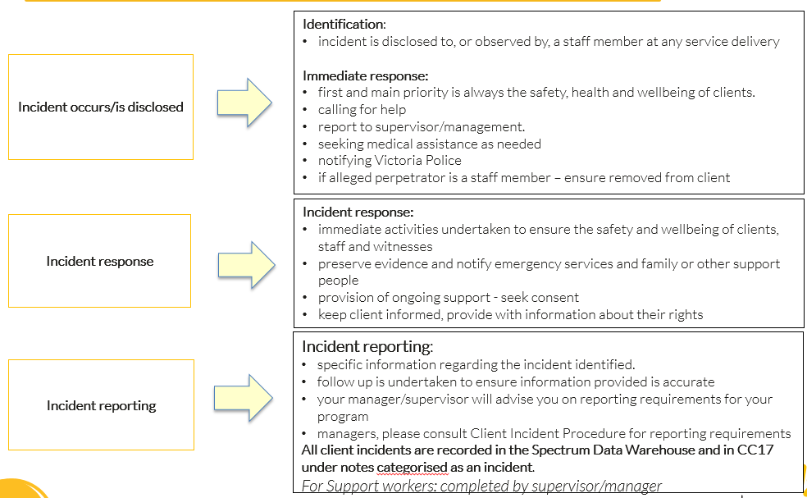

EAP is available to provide you with free, independent and confidential counselling.

If you think the EAP service may be of help, simply call contact the MHSS Office staff to confirm the contact details

Support worker injury
If you injure yourself whilst on shift, it is a requirement that you contact the office as soon as possible. If requested, you will be required to complete an injury report form, which needs to be sent back to the office within 24 hours of the injury-taking place.
You may also be requested to provide a medical clearance from your treating health professional, to provide clearance to return back to your regular duties.

Infection control
Common ways infections are spread include:
- Coughing and sneezing
- Throat and nose discharges
- Fecal contact
- Orally
- Skin contact
- Contact with blood and body fluids
Practice standard principles of infection control to prevent the transmission of blood borne or other infections which may be spread through contact with body fluids that are airborne, ingested, on the skin or on other surfaces.

Hand washing
Thoroughly wash hands and use anti-bacterial hand wash:
- Before handling food
- Immediately after handling raw food, especially raw meat or poultry
- After using the toilet
- After handling money
- After blowing your nose, sneezing or coughing
- Between client visits

Prompting of Medication
Many clients will require prompting of medication; such task will be stated on the clients care plan.
Support workers can ONLY PROMPT medication.
Support workers you ARE NOT to administer medication.
Call the office immediately if the client is unable to take their medication or you notice any concerns regarding their medication.
Medication:
- Do not fill a dosette box for a client
- Only purchase medication if authorised by Case Manager/ MHSS Team.

Elder abuse, child abuse and abuse of vulnerable people
Abuse may take the form of physical, emotional, mental, or sexual abuse or neglect. Some signs of possible abuse include:
- Unexplained physical injuries
- Dehydration or lack of food
- Poor hygiene
- Nervous behavior in the presence of a particular individual
- Reluctance to talk openly and avoidance of face or eye contact
Should you observe any signs of abuse, you must report them to Spectrum office immediately.
Even if you are experiencing uncertainty about a situation, the best thing to do is to discuss it with the office team.
- To do nothing because you are unsure is not an appropriate course of action.
- You may also have concerns regarding the financial management of a client’s funds. Report any area of concern to the office who will follow up in an appropriate manner.
- All abuse issues are to be treated with the utmost respect and discretion.
- Report only what you see without making any judgements.
- We all have a duty of care to ensure the safety and wellbeing of the clients we serve.

Support & Supervision
Supervision by your, coordinator, senior managers and Spectrum Executive enables care workers to improve the quality of service they provide to service users.
The aim of a supervision session is to:
  - Enable the achievement of high standards in the workplace
  - Increase the safety of service users
  - Provide learning opportunities so as to enhance the quality of work
  - Develop an awareness of the workers roles and responsibilities
  - Clarify the aim of the workplace
  - Establish clean and unaccountable practice
  - Give feedback about performance
  - Build professional competence, creativity and new ways of working
You will be required to participate in three (3) monthly Support & Supervision sessions. These sessions are an opportunity to increase your knowledge base, your confidence in dealing with clients and support your ability to carry out your work. It also provides an opportunity to enhance your understanding and knowledge of Spectrum’s processes so that you can perform your job more safely and within the scope of your job role as a Spectrum Support Worker.
Community Support Services Guidelines
Duty of Care
Your ‘duty of care’ to your client is to do your job properly to the very best of your ability, training and resources available. You are also to take reasonable care to protect you own and your work colleagues health and safety.
The law requires staff to take all reasonable care in carrying out their work and ensuring that appropriate standards of care are met. You are to follow all the directions and instructions given in your orientation, training, and Spectrum’s policies, procedures and work instructions.
Spectrum has a ‘duty of care’ to provide you with a safe working environment and give you appropriate directions and support. Your client has a ‘duty of care’ to provide you with a safe working environment.
Clients are allowed to take ‘reasonable risks’ and exercise choice and control in their daily lives, but if you have concerns about any behaviour by clients or family members which you feel would result in unreasonable risk or harm, report this to the MHSS Office immediately. You are expected to use your professional training and experience to determine the level of risk in each situation.
‘Duty of care’ is breached by failing to do what is reasonable or by doing something unreasonable that results in harm, loss or injury to another. This can be physical harm, economic loss or psychological trauma.
To ensure that this duty of care to a client is met, you are expected to provide a competent standard of care to clients within the scope of your role and training. Undertaking activities that are not within the scope of your training and competency may compromise client safety and may be in breach of the law. In summary if your actions are considered deliberate, either in what you do or don’t do, and this causes harm to a client you are likely to face disciplinary action and in extreme cases could potentially be liable for a criminal charge of negligence. Seek advice from your MHSS Office Team if you are unsure of what to do in any situation.

Client Property
Client Property Damage
You are expected to provide all due care when you are working with clients. Accidents sometimes happen and if anything is broken, householders can usually claim for breakages to replace the item(s) on their house and contents insurance. Spectrum may assume responsibility to replace the item(s) if it is confirmed that a Support Worker is responsible for the damage. Damage to a client’s property is to be reported on a Client Incident Report. The MHSS Office Team will then investigate the matter and appropriate action will be taken.
Handling Keys and Key Safe Codes
Ask your CSS Office Team if you are unsure how to enter a Key Safe Code, they will provide you with a demonstration.
You are not permitted to hold keys to a Client's home or to have knowledge about where a client may store spare
Key Safe codes are only provided to keys. This is to protect you as well
Support Workers for the purposes of service provision, when there is no alternative means of access to the client’s home, for example, to assist a client who lives alone to get out of bed.
If a client or family member requests for you to hold a key or insists on telling you where spare keys are stored, please advise the MHSS Office Team.
Client Non-Response to a Scheduled Visit
If the client is not answering the door try knocking on a window or back entrance. Some clients may take some time to answer. If there is still no response, contact the MHSS Office Team who will ring the client's telephone number to tell them you are at the door.

You are NOT to enter a client’s property in the absence of the client unless permission has been given by the MHSS Office Team. The carers contact details will be confirmed to support a worker to contact the carer in the case of emergency when shifts surpass
- 20h00 weekdays and
- 15h00 weekends

Complaints Resolution for Clients
It is always important to deal with concerns and complaints made by clients. If we don’t know about it, we can't fix it.
Your work and Spectrum’s work can always be improved. Complaints can be seen as an indication of what might need to be improved or explained.
Clients are encouraged to comment about service quality and are provided with a Spectrum and external agency Suggestions, Complaints and Compliments Form as part of the Agency Information Pack.
You are encouraged to make every effort to resolve a simple complaint or care issue at an informal level in an informal manner.
Where an issue is raised and cannot be settled immediately, you need to encourage the client and/or family members to contact the MHSS Office Team or Agency case manager. Immediately report any potential or actual complaint to the MHSS Office Team, including complaints that have been resolved.
The Rostering Coordinator or Support Worker Coordinator will deal with the issue according to the Spectrum Resolution Procedure. Depending on the seriousness of the complaint, it may be dealt with by the Manager of the MHSS Team.
Respecting Client Diversity
All Support Workers are to be aware of the need to assist clients in a way that demonstrates respect and support for their personal, social, religious, cultural or sexual preferences. Being aware of how a person’s culture may inform their behaviours, beliefs and values will assist you in providing person-centred care.
Where possible and appropriate, you will be matched to the client’s preferences.
Disciplinary Action
- Disciplinary action is the formal process undertaken by management with individual employees when a performance issue has occurred.
- Disciplinary action will be undertaken when an issue has been raised about the conduct of a staff member.
- This may include failure to follow policies and procedures, a breach of duty of care, breach of confidentiality or failure to act or acting unprofessionally.

Disciplinary action will generally (but will not be limited to) following a standard process:
- Verbal discussion of the incident
- Verbal warning
- First written warning
- Second written warning
- Dismissal

- Instant dismissal (dismissal without prior notification) can proceed where the behaviour is considered to be clear, serious and wilful in nature.
- Depending on the severity of the incident, dismissal could be instant. Such behaviour may include( but are not limited to)
  - theft
  - accepting or requesting financial assistance from the client or the family,
  - fraud
  - use of physical violence,
  - use of drugs or alcohol during working hours.
- All steps will be documented and a record kept on the individual staff person’s personnel file.

Occupational Health and Safety
Your workplace is usually the client's home or it may be for example, the local supermarket or doctor's clinic for the time spent there with the client
An Occupational Health and Safety (OHS) Assessment is made of clients’ homes before you begin providing service. Generally, this is undertaken by the Spectrum or External Case Manager, Program Officer. If any hazards are identified these are rectified or minimised prior to your first visit.
When you visit the client for the first time, you need to observe whether there are any health and safety issues. You may be asked to complete an In Home OHS Record for a private or other service provider’s clients. This is completed by you and returned to the MHSS Office Team as soon as possible or with your roster/timesheet.
If a hazard is noted, you are to follow the OHS Alert procedure and notify the MHSS Office Team immediately if there is potential for serious injury. Your MHSS Office Team can assist you to complete the digital OHS report. You will be notified by the MHSS Office Team about the outcome.
Some key details that are important to note include whether the:
- Client has approved cleaning products available
- Hot water is likely to burn the client or CSW
- Vacuum cleaner and/or other tools and equipment is working and of acceptable lifting weight
- Mop and the bucket are suitable for use
- Pet dog/cat or other animals are able to be contained if required
- Client is cooperative about having home or personal care tasks completed Client or other family members are smokers
- Client has a working smoke alarm
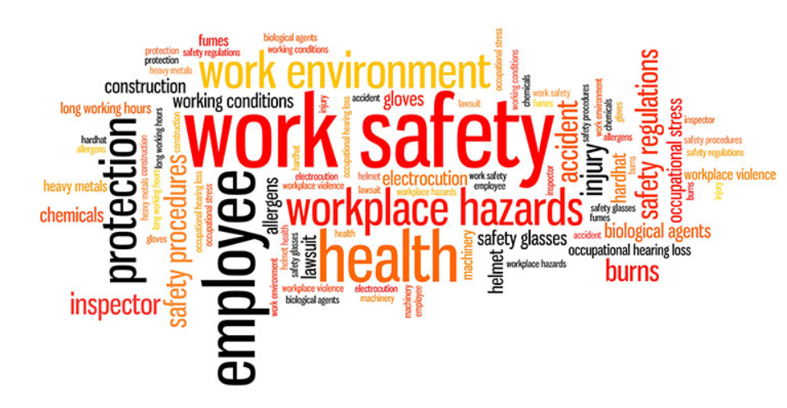

When a Health and Safety issue has been raised, all staff concerned — the MHSS Office Team, and other Support Workers who visit the client and Case Managers, are advised. If the client, family or other service providers are at risk, they are advised as well.
The MHSS Coordinators or External Care Managers are responsible for ensuring that health and safety issues are dealt with. The issue may be fixed or the risks minimised as much as possible. For example, Spectrum Support Worker tasks may be changed or additional training provided.
All staff concerned are advised so that they know what the outcome is.
Health and safety checking don’t stop after the first visit.
EVERY time you visit a client's home, and especially when tasks are changed, you need to be aware of health and safety issues and any possible risks for staff and client.
If you have any Occupational Health and Safety concerns. Talk with the MHSS Office Team.
The important part of Health and Safety is being observant and to act promptly in reporting any risks or hazards. A simple way of practicing this is to look at your own home and imagine what it would be like for someone else providing home care or personal care services there.
For example:
- A shower over a bath may not be a problem for you, but could it be difficult to assist another person to have a shower?
- You may be used to an uneven path or steps, but could they be hazardous for someone not used to them?
- Do you have to move heavy furniture to clean in your own home?
- Do you need to use a stool or chair to put household items in a cupboard?
Clients can and change things, and new hazards can appear between one service and the next. If this is the case, you are to contact the MHSS Office Team and complete an OHS report as soon as possible.
If you are concerned about a particular situation, but are unsure if it is a hazard, talk to the MHSS Office Team about your concerns.
Occupational Health and Safety Incidents happen because of an Unsafe Act or an Unsafe Environment or a combination of both. Given that you are likely to come across unexpected hazards in clients’ homes from time to time, it is very important that you know how to work and behave in a safe manner and to put that knowledge into practice at all times.
Home Visiting & Staff Safety
It is recognised that staff safety is a potential hazard within the area of visiting people in their own homes. Support Services involves staff members entering into environments where events may occur which cannot be anticipated. These events may relate to either people in the surrounding areas such as in high rise flats / rooming houses, or the client / family if their medical condition becomes unstable. You are never to enter into a situation if you assess there is a threat to your safety.

You’re OHS Responsibility
Every employee has Health and Safety responsibilities. The best and safest outcomes are as a result of a partnership of responsibility with SCC (Vic) and your clients for everyone’s well-being.
You are responsible for behaving in a manner that does not risk your own health and safety in your workplace and, to a degree, that of any other person.
You are expected to exercise personal judgement in undertaking duties as detailed in your Position Description. If you believe an action is unsafe or beyond your capacity you are not undertake it. Contact the MHSS Office Team immediately and discuss your concerns.
WorkSafe provides guidelines for safely undertaking all the duties provided by Spectrum including home care and personal care tasks. We have used these to provide you with information in this Handbook about the ways to undertake these tasks. Read them and use them to help keep you safe and healthy.

Health & Safety Guidelines
Hazards are not simply physical such as a loose floor mat or a client with limited mobility. There are also chemical hazards, electrical hazards and biological hazards.
Some examples to be aware of are:
- Be aware of your own safety at all times
- Ensure that your training in manual handling and lifting is up to date at all times and that you comply with the training requirements
- Leave the house if you feel unsafe with the client or other persons present and contact the SCC Office Team immediately
- Ensure your mobile phone is fully charged and with you at all times so that you have some means of communication
- Ensure that someone is aware of when you are expected to return from work
- Report all concerns, however trivial or vague, to the MHSS Office Team immediately
- Ensure you have emergency call phone numbers with you at all times Never allow yourself to be locked in a house Ensure all rooms are well lit and that you are able to move around freely
- Use your Safety Switch with any electrical appliance at all times — it can save your life. Never have wet hands near electricity
- Do not use double adapters Always turn electricity off at the wall before connecting or disconnecting plugs
- Always fill hot water bottles with hot but not boiling water and always wear gloves to protect your hands
- Lift close to your body, bend your knees and keep a straight back
- Alternate tasks regularly — e.g. don’t vacuum for more than 15 - 20 minutes at a time
- Do not wash floors on hands and knees or wash heavy curtains, lift or remove heavy furniture or climb on furniture or ladders to perform any home care duty Use the Approved Cleaning Products information in this Handbook
- Wash hands between tasks or use antibacterial hand sanitiser — observe standard precautions
- Always wear gloves when handling body fluids
- Wear gloves for all tasks if you have dermatitis or cuts of the hands and if necessary, see your Doctor
- Do not attempt any activity you do not feel confident undertaking or have not been trained to provide
- Wear flat-heeled, close fitting shoes that cover the feet for work. Do not remove shoes when entering client’s homes or whilst undertaking duties
- Stay fit and healthy- you owe it to yourself to keep fit, have regular exercise (do some stretches and warm-ups before work
- Remember - being hasty can cause accidents. If you do not have sufficient time for your tasks, ask the MHSS Office Team for your time allocation to be reviewed Attend training sessions on safety issues

Hazard and Risk Reporting
A “Hazard” is anything that may cause injury, property damage or loss
A “Risk” is the likelihood of injury, property damage or loss as a result of the hazard
If you encounter a hazard or risk at a client’s home, you are to notify the MHSS Office Team immediately and report it. The identification of hazards is important for your client’s future safety as well as your own and that of other Support Workers.
Incident Notification
An “Incident” is an accident, event or circumstance which results in harm to a person or property or loss or damage to property or has the potential to do so. The incident may have involved the client, client's family member, the client’s property or yourself. An incident can include an injury, whether obvious or not.
You are required to notify the MHSS Office Team immediately of any accident, incident or near miss.

Manual Handling
“Manual Handling” is defined as any activity that requires the use of force exerted by a person to lift, lower, push, pull carry or otherwise move, hold or restrain any person, animal or thing. It covers the activities of lifting, carrying, pushing, pulling, and sliding.
Carrying Pushing Pulling
Manual handling training is provided by Spectrum and is compulsory for all Support Workers to attend.
Take a new look at Manual Handling If what you are trying to do makes you ‘hold’ or ‘catch’ your breath then the load on your body is too great, irrespective of how easy the task appears.
Safe Manual Handling Skills
DO’s
- Assess and plan the task
- Get close to the client or load and place feet apart for balance
- Bend at the hips and knees but not beyond a right angle and get a good grip
- When lifting, brace the core muscles, maintain the “S” curve and straighten your legs. This way you are using the strong thigh and calf muscles
- Lift and turn your feet keeping the centre of gravity of load and body in line with the feet
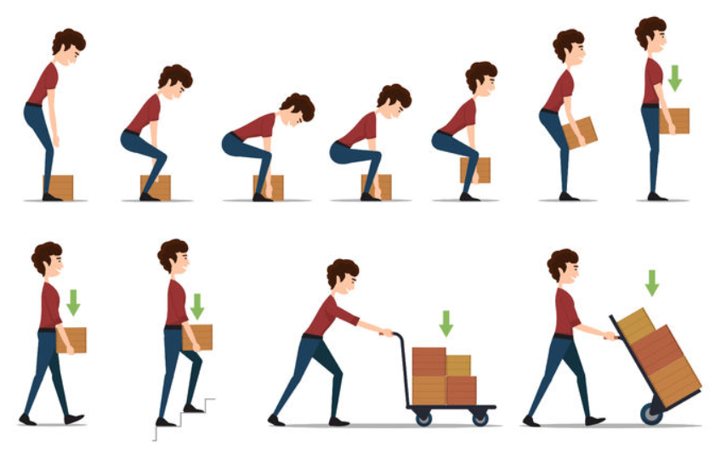
- While carrying, clasp the load close to the body

DO NOT’s
- Do not turn the body or head while lifting. Lift, and then pivot on feet
- Do not ‘snatch’ a load, rather slowly accelerate it
- Do not use the weak back muscles to lift
- Do not rush the task or allow yourself to become distracted from the task.

General Principles of Mopping, Sweeping and Vacuuming
- Not to be performed consecutive to each other
- To alternate with other tasks e.g. laundry, cleaning bathroom, meal preparation
- If rooms are large, to clean one room at a time and alternate with the other tasks

MOPPING
- Fill bucket while it is on the ground, using a jug and tap hot water, never use boiling water
- Do not fill more than 1/3 bucket capacity
- Position bucket in central area when mopping and take the mop to the bucket- DO NOT carry the bucket around. Ensure empty if carrying upstairs
- Floors are to be mopped once with detergent, then with a dry mop
- Ensure you or the client do not walk on the wet floors due to risk of slipping
- Report if bucket is of old heavy metal or wringer is not working properly

SWEEPING
- If sweeping outside, avoid the task if very windy
- If sweeping large areas, use face mask
- Replace sweeping with vacuuming wherever possible (inside)
- Report if broom needs replacing

VACUUMING
- Never use an upright vacuum cleaner to do the stairs
- Do not carry vacuum cleaner up the stairs-the client is to provide a cleaner to be used upstairs as required.
- Do not run over the power cord
- Check and empty the bag/canister before you start vacuuming as if they are full the suction will be reduced
- Check there are no loose threads, strings, etc caught in the vacuum head prior to vacuuming as you would require more effort to push the cleaner
- Clear the area of large items that you do not want suctioned into the vacuum cleaner before you start.

Infection Control
Transmission of infection. There are 3 primary ways infection is spread-

Contact transmission. Involves transmission by touch or via contact with blood or body substances. This can be via direct transmission such as when a client’s blood enters a staff member’s body through a cut in the skin. Or indirect transmission, when a staff member who may come into contact with a client’s bodily fluids, transfers infection by not washing their hands (or on their soiled clothes) to either themselves, or to someone else. Example - skin infections or infestations.

Droplet transmission. Occurs when an infected person coughs and sneezes. Droplets transmit infection when they travel directly from the respiratory tract of an infected person to the nose, eyes or mouth of another person. This usually occurs over short distances of about a meter. However, droplets can also be transferred indirectly via hands. Example – the flu virus.
airborne transmission. Occurs when very small airborne particles containing infectious agents are inhaled. Examples – measles, chickenpox and tuberculosis.

Other modes of transmission. Contaminated food or water.
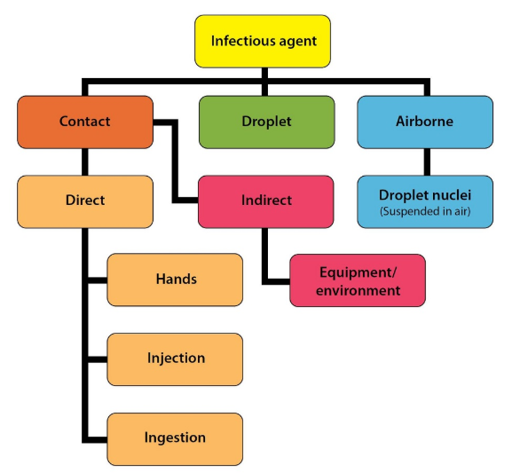

Hygiene Precautions
- It is important to protect the safety and health of both clients and Support Workers by reducing the risk of disease and cross infection.
- You are to adopt the following principles of good hygiene:
- Maintain good personal health and hygiene e.g. keep vaccination such as flu up to date and shower and change clothes daily
- Use protective equipment e.g. plastic aprons if clothing is likely to be soiled
- Wear disposable gloves for personal care such as showering and toileting (discard gloves, wash hands and change gloves between uses e.g. handling soiled items, and especially between clients or if the glove is punctured)
- Wash hands using soap and warm water: after going to the toilet; after touching your nose or hair; after cleaning jobs (especially areas such as bathrooms, laundry and kitchens); before handling or preparing food
- Use antibacterial hand sanitiser if hand washing facilities are not available or are inadequate for the task.

Hand washing Techniques
- Wet hands thoroughly with soap for about me 10 seconds
- Use a neutral soap if available.
- Rinse well under running water
- Pat dry with a paper towel
- Apply a water-based moisturiser to keep skin supple
- Hand disinfection between client contacts by using antibacterial hand sanitiser ensuring all skin surfaces are covered.

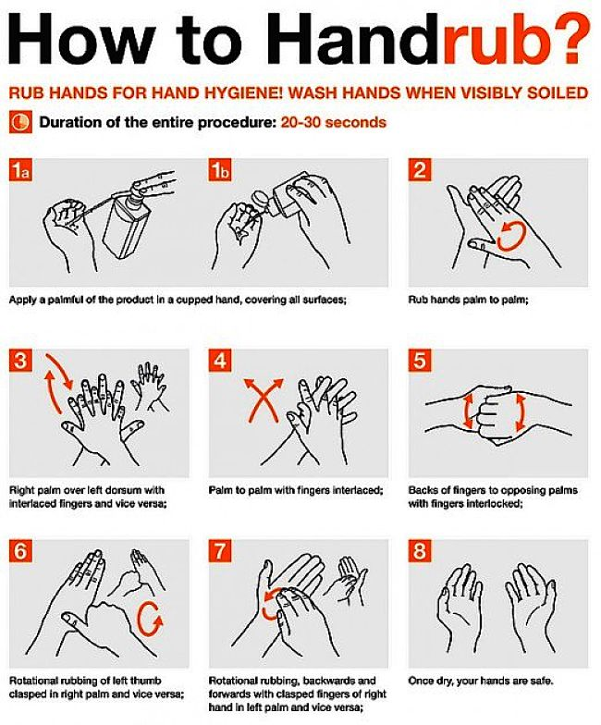

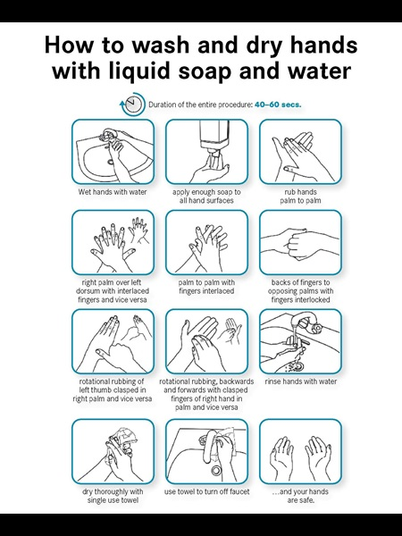

Standard Precautions
- Standard Infection Control means treating all bloods and body fluids as potentially infectious. The same precautions need to be used in all households regardless of the state of health of the client (which may be unknown in the case of HIV/AIDS or hepatitis)
- Any body fluids may be infectious. These include not only visible blood, but also semen, vaginal secretions, urine, faeces, saliva, sputum and secretions from open wounds. Skin and mucous membranes are to be protected against such substances by protective barriers such as gloves to reduce the risk of exposure to infection. If splashing is likely to occur, wear a plastic apron to prevent contamination of clothing
- Safety lens glasses and a mask may also be necessary to protect your eyes and mouth in some circumstances e.g. safety glasses are to be worn when undertaking the home care task of cleaning a client’s toilet
- Care is always to be taken to prevent the splashing of blood or body fluids into eyes, nose and mouth. Safety lens glasses are to be worn and are to be washed and dried after use
- If you have any cuts, grazes or rashes, cover them with a protective waterproof dressing and wear gloves
- Take care to prevent injuries from sharp objects that may be contaminated with blood e.g. needles or broken glass. Contact the MHSS Office Team if the client does not have access to a sharps disposal container for any sharps/syringes they produce
- Wear gloves and a mask when emptying a vacuum bag
- Take care to prevent contamination of the environment by body fluids. For example, dispose of soiled sanitary or incontinence pads (including the gloves used to handle them) by putting on fresh gloves and then double bagging - putting contaminated materials in a plastic bag, tying the top securely then putting into a second bag and tying this securely
- Wipe up accidental spills of blood or other body substances- wearing gloves, safety lens glasses and apron- by using toilet paper, tissues or paper towels, then dispose of any solid matter by flushing it down the toilet
- Thoroughly clean surfaces and equipment which have been contaminated with blood or other body substances wearing gloves, safety lens glasses and apron by CAREFULLY using warm soapy water and disposing of paper towels and other non-flushable cleaning items by double bagging
- If exposed to blood or body fluids, immediately and thoroughly wash hands and any other skin surfaces that are contaminated with soap and water. If the exposure is to your eyes, immediately splash with water. Report to the MHSS Office Team without delay.
- REMEMBER - The best protection against infection is thorough hand washing with soap and water. Always wear disposable gloves if in contact with blood or other body substances. Antibacterial hand sanitisers can also be used if hand washing facilities are not available or are inadequate.

Chemicals
Most chemicals in the home are potentially dangerous if misused, but there are some which are hazardous even if used properly. These types of chemicals, as listed below, are not be used even if your client requests that you do so.

All clients are provided with a list of Assessed Cleaning Products/, Recommended Cleaning Equipment and OHS Guidelines. If the client does not have this, please contact the MHSS Office Team and they will arrange with internal and external case managers.
General Principles of Safe Chemical Use
- Do not use chlorine bleach
- Do not use ammonia-based cleaners
- Do not use caustic cleaners
- Do not use pressure-pack aerosols
- Always read the safety instructions on chemical containers and follow the instructions
- Use hand-pump sprays carefully, and only spray from a short distance into your cleaning cloth, not onto a surface. Check the nozzle is facing away from you before activating
- Never mix chemicals
- Use chemicals only in a well-ventilated space
- Do not clean showers from the inside with the door or curtain closed. Use exhaust fan or open window if available
- Wear gloves at all times
- Never use chemicals if they are not stored in their original containers
- Thoroughly rinse all chemicals from cleaned surfaces and cloths. Residues may be harmful to your client.
Vacuuming / Sweeping / Mopping
- Limit vacuuming/sweeping/mopping to 15 - 20 minutes at one time. If more
- is required to be done, change to another task with different body movements and then return to vacuuming/sweeping/mopping.
- Do not vacuum whilst standing on stair treads — only vacuum from bottom or middle landing.
- Do not carry heavy or upright vacuum cleaners up and down stairs.
- If the home is on two levels, it is best to have a vacuum cleaner available for each level of the home. If not, the vacuum cleaner is to be lightweight or easily disassembled so it can be carried up the stairs
- If stairs are to be vacuumed, a long handled, light weight, cordless, stick style vacuum cleaner is recommended for use
- Do not hand wring mops — use push down mop buckets, or light weight plastic buckets
- Do not use boiling water — for any cleaning purposes
- Only use chemicals and cleaning products that have been approved for use. Do not use any chemicals which have been decanted into other containers or that are not labelled clearly
- Do not move heavy furniture and do not lift furniture
- To test ease of movement of furniture, use the “nudge test.” Nudge the furniture with the knee or thigh — if it does not move easily, do not move furniture
- Only move sofa/bed if on castors and the castors run smoothly across the floor surface
- Do not lift long/large mats
- Do not over reach or stretch into an awkward body posture
- Do not climb onto furniture (including stools) or ladders
Vacuum cleaners are to have the following features:
- An adjustable wand &
- A flexible hose
AND:
- Be well maintained
- Stored at a height and location which can be safely accessed by the worker
- Be easy to empty or preferably have disposable dust bags
- Be easy to move around and lightweight
- Have good suction

For Occupational Health and Safety reasons upright or heavy vacuum cleaners, and those which are awkward to move may need to be assessed by the Case Managers or Agency Leaders before the Support Worker can undertake any vacuuming.
Examples of Vacuum Cleaners
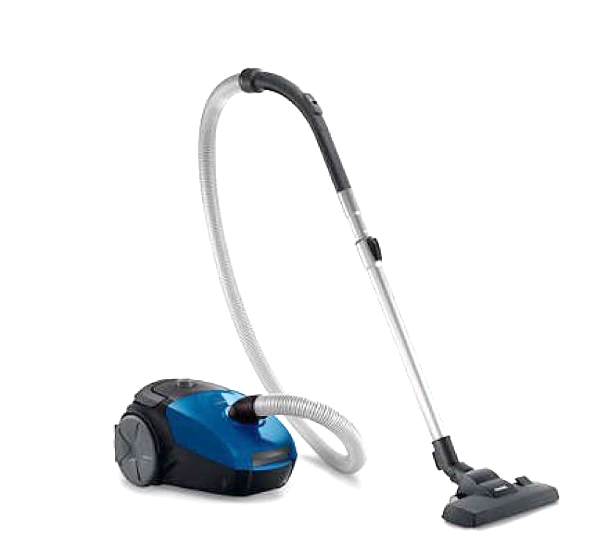
We recommend provision of a light- weight barrel style vacuum cleaner-examples pictured below
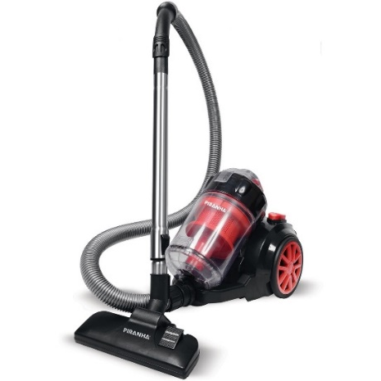

Examples of Mopping Equipment
Pictured below are preferred mops and buckets for use by Support Workers

Flat Mop
- Especially suitable for large Bucket and Wringer: areas of tiled or timber floors. Suitable for general use.

Bucket and Mop Combo
- Small or medium only

Oven Cleaning
- Do not clean ovens that require heavy cleaning. Advise the MHSS Office Team if this is required “No heavy scrubbing is to be undertaken

Making Beds
- Do not lift or turn a mattress when alone or even with another person, if the mattress is heavy and/or awkward. Limit tucking in sheets and blankets to the ends of beds only; leave sides untucked if working in confined spaces.

Removing Cobwebs / Dusting
- Use a long handled, lightweight cobweb brush
- Do not reach above shoulder height to dust in high places
- Do not use a vacuum cleaner to remove cobwebs
- Do not stand on furniture or ladders to dust
- Do not change curtains

Ironing
- Limit ironing to 15 - 20 minutes at one time. If more is required to be done, alternate with other tasks that require different body movements

Showers
- Use anon slip mat both inside and outside the shower/bath when showering clients
- Use a long-handled scrubber to minimise over reaching.
- No scrubbing on hands and knees when cleaning shower/bath

General: Spectrum Support Worker staff are not to:
- Remove shoes upon entering client's homes
- Undertake tasks that are not listed on the task list/care plan unless permission is gained from the Community Services Office Team
- Perform heavy cleaning home care duties on days of extreme heat or/heat wave
- Use electrical equipment without an electrical Safety Switch
- Use equipment that appears faulty
- Work in the client’s home when the client is not at home. You are requested to remain in the home while the Support Worker is present
- Have keys to the client’s home or the client's phone number
- Use the clients banking pin number or have knowledge about client’s pin number
- Witness any legal document signing e Run errands that are not authorised e.g. go to the shops to pick up milk e Provide clients with their personal contact details
- Visit clients out of scheduled visit times unless permission is sought from the CSS Office Team
- Bring their children/grand children to the client's home or during service provision
- Work in homes where there is a threat to their personal safety
- Work in homes where people are smoking, drinking alcohol or taking illicit substances
- Work in homes where animals are unable to be contained
- Undertake tasks normally performed by Registered Nurses e.g. wound dressings or medication administration
- No industrial chemicals including unlabelled cleaning detergents are to be used by a Spectrum Support Worker, Hazardous Chemicals Not to be Used including hospital grade disinfectant

Food Safety
Many clients will need you to purchase food, prepare food for them or assist them to prepare it.
Regular news reports carry stories of food poisoning outbreaks and even deaths as a result of careless handling of food. So, it is important to handle and store food safely.
As with the Standard Hygiene Precautions, all raw food is to be treated as potentially contaminated and is to be handled accordingly. The information in this section is a guide to basic safe food handling.
Germs don't discriminate between food prepared at home and food bought at a restaurant. In fact, almost all raw food has some bacteria on it, and if you don't treat it correctly, the result can be food poisoning.

There are some simple rules that you can follow to lessen the chance of food poisoning for a client:
- Always buy food from a reputable supplier
- Always take fresh and frozen food straight home after buying it, particularly in summer. Think about using an insulated cool bag to protect the food from summer heat and prevent germs from multiplying
- When you get home, place fresh and frozen food straight into the appropriate compartment of the fridge.
Fridge
- Hot food is to be cooled quickly before placing them in the fridge or the fridge temperature will rise
- All food in the fridge is to be covered
- Store raw and ready to eat food separately with raw foods on the bottom shelves and ready to eat above, so liquids from raw foods do not drip onto ready-to-eat foods
- Food is to be used before its 'Use by' or 'Best before’ dates
- Defrost the fridge regularly to help it operate efficiently.

Freezer
- NEVER refreeze foods that have been thawed
- If you're freezing cooked food, smaller containers will freeze and thaw faster, which can help protect against food poisoning
- Marking the date on cooked food you're freezing will help you keep track of what's in your freezer
- Don't freeze food unless it's completely fresh, because germs that are in it can start multiplying while it's thawing
Working in the Kitchen
- Always wash your hands before preparing food and wear gloves when preparing food in a client's home
- Use separate utensils for raw foods (meat, poultry) and ready to eat food (cooked meat, salad, cold meats)
- Don't prepare food if you are feeling sick
- Keep pets out of the kitchen - ask the client to please contain the animal
- Thaw frozen food on the bottom shelf of the fridge
- Cook meats, especially minced meats, until the juices run clear, and there are no pink areas
- Don't reheat food more than once and when reheating make sure food is piping hot
- If using the microwave to thaw food, cook thoroughly straight away.

If you are worried about food you have bought or about the cleanliness of a shop or other food premises, you are to first contact the MHSS Office Team who may advise the Environmental Health Officer in the Council area where the food premises is located.
If you are concerned about the food storage facilities or about the cleanliness of a client's home please speak with the MHSS Office Team.
Never cook food for a client in your own home.
Electrical Safety
Water conducts electricity. Never touch electrical appliances or switches with wet hands.
Frayed electrical cords, broken switches and sockets are very dangerous. Notify the MHSS Office Team immediately if you notice these in the client's home.
Always use the Safety Switch provided and ask the MHSS Office Team for a demonstration if you have any concerns about how to use a Safety Switch.
Using a Safety Switch
A Safety Switch is included in your Community Support Worker’s Kit and is always used when working in a client’s home.
Please remember:
- Always test the Safety Switch before using it. If it fails the test, do not use and do not use any electrical equipment. Phone the MHSS Office Team who will advise you of alternative working arrangements until a replacement Safety Switch can be provided.
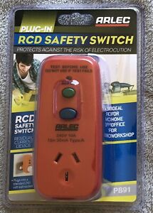
- Return the faulty Safety Switch and complete the Support Worker’s Kit Reorder Form to obtain a replacement from the MHSS Office Team.
- Keep the Safety Switch dry — never put in water and allow rain to get on to it. It is designed for dry conditions
- Do not allow the Safety Switch to come into contact with petroleum, detergents or cleaners
- Never plug the Safety Switch on to an extension lead. It is always to be used on a fixed power point
- A Safety Switch cannot protect you against exposed cables. Notify the MHSS Office Team immediately if you notice these
Test Procedure:
- Plug into Socket Outlet and switch on
- Press RESET, check indicator is at Red (ON)
- Switch Socket Outlet off. Red indicator must disappear (OFF)
- Switch Socket Outlet on. Press RESET (ON)
- Press TEST. Red indicator must disappear (OFF) If device passes the above test, plug in appliance and press RESET>
Do NOT USE if device fails test.
Safety Switches are to be tested and tagged every two years- you will be reminded by the MHSS Office Team to bring in your safety switch when it is due for testing.
Please ensure you have your electrical safety switch with you when you leave the clients home and not leave it behind. You may be charged for a new electrical safety switch if you lose or misplace your electrical safety switch.
Transporting Oxygen tanks
If a client requires oxygen for use on outings and you are required to transport it in your vehicle, please be mindful of the following information.
- Oxygen tanks are heavy and can be a potential fire risk or a projectile if not handled or transported correctly. Oxygen bottles are not to be carried in the front seat.
- You are to secure the Oxygen tank inside the bag and fasten with the seat belt on the back seat
- Or if a larger style trolley is used - it is to be placed on the back floor of the vehicle with the toe of the trolley hooked under the front seat or alternatively it is placed on the back seat and fastened with a seatbelt
- Some suppliers advise that a window is left open a little in case the oxygen tank is leaking
- If clients do not have any of these options available or refuse to use them please contact the MHSS Office Team.

Pets/Animals
An assessment of the risks of the pet/animal is to be undertaken prior to services being provided.
This includes an assessment of the following:
- ls the pet/animal able to be contained/restrained whilst the Support Worker is working in the home
- Risks associated with walking the pet/animal e.g. is it used to being walked on a lead?
- ls the environment where the pet/animal is to be walked safe for the Support Worker
You are to:
- Use Personal protective equipment (PPE)in collection of any waste material
- Report any concerns to the MHSS Office Team
- Remove themselves from the environment if they feel at risk of harm
Emergencies : In the event of a car accident
- STOP
- Protect the area to make sure another accident does not occur
- Ensure that your situation is as safe and secure as possible
- Give assistance to any injured person
- Phone 000 for Police and Ambulance or 112 if using a mobile phone
- Remove all debris from the road (if safe to do so)
- Ensure that the exact location of the accident is noted, together with time and condition of road e.g. slippery following heavy rain
- Record the names and addresses of as many witnesses as possible at the scene of the accident including the name/number of the attending police officer If there is any property damage and the owner (or representative) is not present, report the accident to the nearest police station
- Report the accident to police if anyone is injured and the police do not attend the accident scene
- Contact the MHSS Office Team by phone to advice of the accident and any details about the client (if relevant) and complete a Client Incident/Accident Report or Personnel Incident Report Form as soon as possible.
Police should attend the accident scene if:
- A person is injured or killed
- The other party fails to stop or exchange details
- The collision is a hazard to other traffic
- There is ongoing danger to people or property
- A driver appears to be under the influence of alcohol or drugs
Record the following information:
- Name, address and phone number of the owner of the other car
- Registration number, vehicle type and colour, licence number
- Name of the other person’s insurance company
- Details and location of accident
- Client name and details
- If anyone involved in the accident is injured, call the police as well as the ambulance.
Give the other person the following information:
- Registration number, vehicle type and colour, licence number
- Address and phone number of your MHSS Office Details
- Names and addresses of witnesses if available.
Client Accident or Emergency Dial 000 and ask for Ambulance
In the event of a client emergency e.g. a fall resulting in injury where the client can’t get up, severe breathlessness, sudden paralysis, unconsciousness or suspected death:
- Check if the client is breathing, if their airway is blocked and if a pulse is present. Proceed with First Aid response as appropriate
- Immediately ring for an ambulance, stay on the line if possible and follow any instructions given
- Stay with the client until the ambulance arrives. Make the client comfortable and/or cover with a blanket if appropriate
- Do not move the client as this may cause them further injury, especially where there is a possibility of a fracture. Moving the client may also cause you to injure your own back.
- Do not give them anything to eat or drink
- Inform the MHSS Office Team as soon as possible

TO ASSIST THE AMBULANCE
- Answer each question calmly and accurately
- Avoid third-party calls: The person with the client has the most current, accurate information (i.e. your MHSS Office Team will ask you to call the ambulance, if you haven't already done so)
- Be prepared to answer the following questions when you call the ambulance:
- What is the exact location of the emergency?
- What is the nearest intersection? Have someone wait outside if possible
- What is your contact phone number?
- What is the problem? (What exactly happened?)
- How many people are hurt?
- What is the age of the client?
- Is the patient conscious?
- Is the patient breathing?
- Ring back on 000 if the patient’s condition changes.
Fire Dial 000 and ask for the Fire Brigade
In the event of fire - only if safe to do so -, remove the client immediately from danger and ensure the Fire Brigade is phoned. Once out of immediate danger, when appropriate, call the MHSS Office Team.
Remain with the client.

Extreme weather conditions
Purpose:
To ensure the safety of clients and support workers during extreme weather conditions.
Spectrum will continue to provide essential services with regard to the health, safety and wellbeing of clients and support workers.
Services will be modified to minimize risks to clients and staff.

Definitions:
Extreme heat - when temperatures reach 38 degrees. You will receive a SMS from the office informing you of the heat alert.
Heat wave - when temperatures for the day and night over a 24-hour period is 30 degrees.
Prolonged heat wave - is when temperatures reach 38 degrees for two or more days.
Essential services – the services that are necessary for the health and wellbeing of a client
Non-essential services – the services that do not put the health and wellbeing of a client at risk if the service is not completed
What do I need to do?
Extreme weather conditions such as heat, wind, floods, rain and hail may affect your shift.
The Office will tell you if your shift needs to be changed or cancelled
Please call the Office:
If your shift needs to be changed
If you have any concerns about applying this policy
If you are concerned about the health and wellbeing of the client
If your client is expecting you to do heavy household tasks
How to keep cool in the heat?
It is important to look after yourself and your client during extreme heat conditions:
Use air conditioning and fans
Pull blinds down
Drink water
Leave drinks close at hand for client
Wear light clothing
Client to have a cool shower – if client is safe to shower alone
Give a cool cloth for face

Client Illness
Do not hesitate to inform your MHSS Office Team of any concerns that you may have regarding the health of your clients. Any change in the client’s health is to be reported. In the event of the client stating that they are feeling ill or if you notice a sudden deterioration in the health of your client, particularly if the client is abnormally:
- Quiet
- Pale
- Breathless
- Not eating
- Confused or agitated

Notify your MHSS Office Team immediately and follow instructions.

Client advises of Infectious illness/Disease
You are to immediately notify the MHSS Office if you become aware that a client has either been diagnosed or come into contact with an infectious illness/disease.
The MHSS Office will provide advice on the next action to be taken

It is highly recommended that staff take up the offer of having the yearly flu vaccination made available to all Spectrum staff.

Dementia Overview
The word “DEMENTIA” is used widely to describe a group of diseases which affects the brain and causes a progressive decline in a person's abilities to remember, think and learn. The main abilities which are affected are: judgement, orientation, emotions, memory, thinking, personality and behaviours
How common is dementia?
Older people do not get dementia. It is not a normal part of ageing. Dementia can happen to anyone at any age but it becomes increasingly common after the age of 65 years.

Types of Dementia
There are different forms of dementia and each has its own causes. Some of the most common forms of dementia are: Alzheimer’s disease, vascular dementia, frontal lobe dementia.

The Brain and Behaviour
When a person has dementia one or more areas of the brain are damaged with the areas of damage different for each person
The person cannot help their behaviour resulting from the brain damage
All behaviour has a reason behind it
Behaviour and psychological symptoms of dementia
Behaviour symptoms include: restlessness, physical aggression, agitation, wandering, culturally inappropriate behaviours, no sexual inhibition, hoarding, cursing & shadowing.

Ten top tips for assisting people who are living with Dementia
- STOP - Think about what you are about to do and consider the best way to do it. PLAN & EXPLAIN - Who you are; What you want to do; Why.
- SMILE - The person, who takes their cue from you, will mirror your relaxed and positive body language and tone of voice.
- GO SLOW - You have a lot to do and you are in a hurry but the person isn't. How would you feel if someone came into your bedroom, pulled back your blankets and started pulling you out of bed without even giving you time to wake properly?
- GO AWAY - If a person is being resistive or acting aggressively, but is not causing harm to themselves or others leave them alone. Give them time to settle down and reapproach later.
- GIVE THEM SPACE - Any activity that involves invasion of personal space increases the risk of assault and aggression. Every time you provide care for a person, they may feel that you are invading their space.
- STAND ASIDE - Always provide care from the side not the front of the person where you are an easy target to hit, kick, etc.
- DISTRACT THEM - Talk to the person about things they enjoyed in the past, or give them something to hold whilst you are talking to them or offer a cuppa.
- KEEP IT QUIET - Check noise level and reduce it. Turn off the radio and TV
- DON’T ARGUE - They are right and you are wrong! The demented brain tells the person they can’t be wrong.
- BRAINSTORM AND DEBRIEF - How can you and your team best meet the physical, environmental and psychological needs of the people in your care?

THINGS TO CONSIDER
- People living with dementia can at times become verbally and physically aggressive. The triggers for these behaviours can be numerous and sometimes requires much investigation and time to identify the reasons behind the behaviour.
- Remember people behave in a certain manner for a reason, aggressive behaviour is no different.
- Think to yourself — why is the person behaving in an aggressive way? Do they have a need which is un-met? What can you do differently to prevent or manage this behaviour?
- Ensure that the person is physically well as much aggressive behaviour is as a result of untreated health condition. Le. UTI, constipation
- Providing the client with as much choice and freedom in their everyday life will lessen the likelihood of verbal/physical aggression arising
- Slowing down your actions, rate of speech and body language is a key to avoiding aggressive episodes
- Is pain, depression contributing to persons behaviour
- Ask for the family to be consulted to investigate how the aggression may have been avoided or managed at other times
- Never argue or shout with a client, simply listening and acknowledging how the person is feeling can assist to diffuse the situation
- lf safe to do so it may be best to leave the client displaying an aggressive behaviour and try again a little later
- Physical and verbal aggression often occurs when staff are rushed and time is not provided to the client. Understand the care to be provided
- Be creative and flexible with your language to find what works. The more flexible you are with your routine and structure the less likely the client will respond with aggressive behaviours
- Ensure your approach and communication is calm, relaxed and clear, do not underestimate the influence of a friendly smile
- Involve the person as much as possible and allow them to make choices where possible
- Could the environment where the aggression occurred be changed? Quieter, less stimulus
- You are required to attend:
- Compulsory training days which provide updates and refreshers

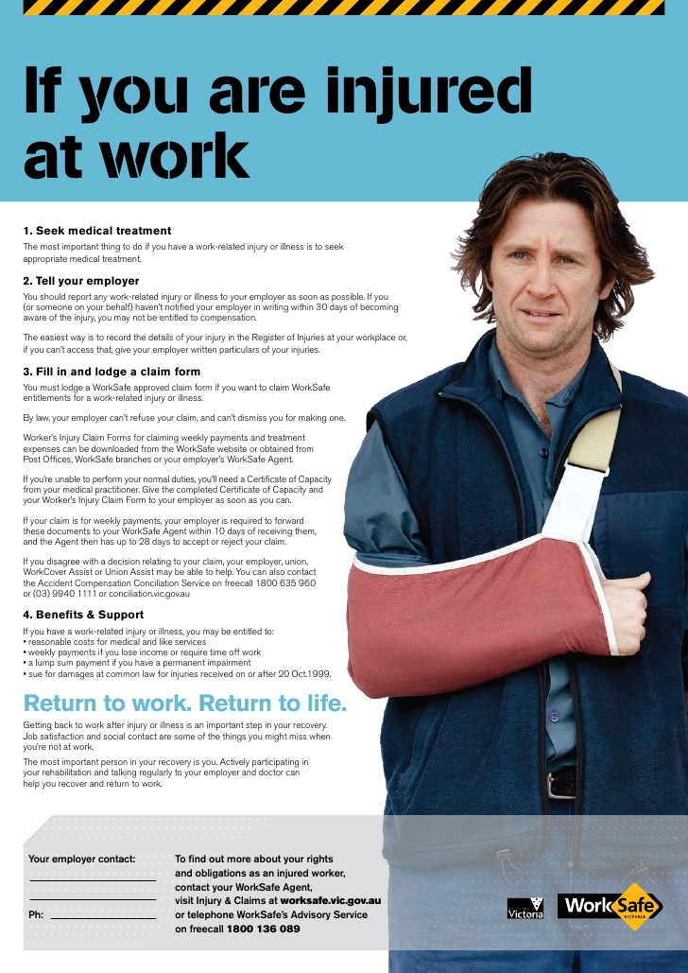
a

Acknowledgment Form

I ………………………………………………..……………………………..have received, read and fully

Understand the above Multicultural Home Support Service Support Worker Handbook Version 1.0 2019
And agree to abide by the terms and conditions.

-------------------------------------- --------------------------------

Support Worker Signature Witness Signature

----------------------------------- | -------------------------------------
Support Worker Name | Witness Name
Date:________________ | Date:______________

